## Quota allocation policies in U.S. federal fisheries management and implications for climate resilience

Christopher M. Free1,2,3, Zoë J. Kitchel1,4, Matthew Seeley5, Allison Shields5

1 Mola Mola Analytics LLC, Santa Barbara, CA, 93101, USA

2 Marine Science Institute, University of California, Santa Barbara, Santa Barbara, CA, 93106, USA

3 Bren School of Environmental Science and Management, University of California, Santa Barbara, Santa Barbara, CA, 93106, USA

4 Vantuna Research Group, Occidental College, Los Angeles, CA, 90041, USA

5 Environmental Defense Fund

### Abstract (195 of 250 word max)

Quota allocation policies, which divide fishing catch or effort between regions, sectors, subsectors, individuals, and/or seasons, are one of the most important and contentious processes in fisheries management. These policies often aim to advance fairness and equity goals by preserving levels of historical participation and access. However, this reliance on historical patterns makes allocation policies vulnerable to climate change, which is shifting the accessibility of marine resources among historical and new fishery participants. Despite this, there is little guidance on best practices for adapting quota allocation policies to climate change. In the United States, regional flexibility to design locally relevant quota allocations has innovated a diversity of policies that can be studied for their climate vulnerability and/or adaptivity. Here, we synthesize the diverse allocation policies used to manage U.S. federal fisheries (507 stocks, 45 management plans, 8 regions), evaluate the vulnerability of these policies to climate change, and provide recommendations for increasing the climate-adaptiveness of allocation policies. We find that… These recommendations are transferable to international and state managed fisheries also seeking to maintain the fairness and equity of their allocation policies under climate change.

**Keywords:** catch allocations, quota allocations, catch shares, climate change, fisheries, climate resilience

**Important documents:**

[Google Drive](https://drive.google.com/drive/u/1/folders/1kqbosva0EdXT2_UcXuVqeMRV35fjDfSo) | [GitHub repo](https://github.com/zoekitchel/cc_allocation) | [Scope of Work](https://docs.google.com/document/d/1JIBhA1CAWbX3eAA26iL_VrJCfJEv1n9K6jrWvh-Hr7g/edit) | [Policy Summaries](https://docs.google.com/document/d/1IA4sohp3QJoGug611efJM7z3JcKW_V5m4HW913QtHfg/edit#heading=h.q27ct8836xj0) | [Policy Database](https://docs.google.com/spreadsheets/d/1vaR-h3o08yI6Aix9LBvBKqORjSR2trBU-l8OBNtncuY/edit#gid=0) | [old text](https://docs.google.com/document/d/1K83U8PDsEws5sjN1FCpTWipBQ9300c_H3fnYpseC4SQ/edit) | [interview protocol](https://docs.google.com/document/d/1JD7VZS5BOqEEVXvPpj0QStzzJ40MgdLdJYcqXJC48rA/edit#heading=h.1tm4v8cp2t6y) | [to-do list](https://docs.google.com/document/d/1_eU_-Rz2j6_hLgEDB2Gf7OYpr-zY707AZ3fGIDVlgiM/edit) | [cover letter](https://docs.google.com/document/d/1aFTkS6uFUXapV8ANTnwLfD29tsUp-xnWghDhZ7T2HAc/edit)

**Target journal:** [Fish & Fisheries](https://onlinelibrary.wiley.com/page/journal/14672979/homepage/forauthors.html)

### 

### 1. Introduction

Climate change is shifting the abundance, distribution, and phenology of harvested marine resources, which is challenging the ability for managers to maintain the conservation and socioeconomic goals of global fisheries [(IPCC, 2019)](https://www.zotero.org/google-docs/?7ZLMgb). To achieve conservation goals, managers must establish catch or effort controls that maintain sustainability as stocks experience climate-driven shifts in their productivity and distribution [(Gaines et al., 2018)](https://www.zotero.org/google-docs/?jxMPcE). To meet socioeconomic goals, managers must further ensure that access to shifting resources remains fair and equitable despite changing oceanographic conditions [(Tokunaga et al., 2023)](https://www.zotero.org/google-docs/?wgAx8N). This can be achieved through a combination of management policies ranging from permitting, which governs who can access resources, to quota allocation, which governs how much catch or effort is available to those with permitted access [(Ojea et al., 2017)](https://www.zotero.org/google-docs/?zOVq6Q).

Quota allocation is arguably one of the most important and contentious processes in fisheries management as it dictates who gets access to fishery resources. While the establishment of catch limits is a largely scientific and objective process [(Punt, 2010)](https://www.zotero.org/google-docs/?fyT3Nr), decisions about how to distribute the resulting quota is more subjective and depends on complex socioeconomic considerations [(W. E. Morrison & Scott, 2014)](https://www.zotero.org/google-docs/?PSeZ5f). Quota allocations are often made between jurisdictions (e.g., international, regional, state), sectors (e.g., commercial, recreational, tribal, research), subsectors (e.g., gillnets, longlines), individuals (e.g., catch shares), and seasons. Allocations are often based on relative levels of historical catch or effort as they frequently aim to maintain proportional access for fishing communities historically dependent on fishery resources [(Cox, 2009; FLSF, 2010; Lynham, 2014)](https://www.zotero.org/google-docs/?uu5QQS). However, climate change is causing rapid departures from historical conditions, which can lead to unfair, inequitable, and inefficient resource use when access is based solely on historical dynamics [(Palacios-Abrantes et al., 2020, 2023; Pinsky et al., 2018; Vogel et al., 2024)](https://www.zotero.org/google-docs/?YXHll1). As a result, fisheries managers will need to develop procedures for adapting quota allocation policies so that they continue to advance their fairness and equity objectives despite changing ocean conditions.

The challenge posed by climate change is perhaps most direct for spatial quota allocation policies as climate change will rearrange the distribution of stocks. Spatial allocations, which allocate quota across different management areas (e.g., countries, regions, states), generally aim to ensure that harvest is proportional to either the biological availability of the resource or the historical dependence of fishing communities on the resource. However, climate-driven shifts in the distribution of marine species imply that historical benchmarks used to set spatial allocations will not reflect future distributions [(Palacios-Abrantes et al., 2020, 2023; Pinsky et al., 2018)](https://www.zotero.org/google-docs/?K7u3lE). This can present a number of conflicts, inequities, and inefficiencies. For example, if allocations are not updated to reflect shifted distributions, some fishing communities may be unable to capitalize on increases in local availability, which would be especially challenging if other species in their portfolio are negatively impacted by climate change [(Cline et al., 2017; Samhouri et al., 2024)](https://www.zotero.org/google-docs/?0V6wHP). Worse still, they may be at increased risk of closure if they are unable to avoid the newly abundant yet tightly regulated resource. Furthermore, vessels from a region maintaining its historical access rights may need to travel farther to fulfill their quota [(Young et al., 2019)](https://www.zotero.org/google-docs/?WNJNb9), increasing both their costs, safety concerns, and carbon emissions [(Papaioannou et al., 2021; Scherrer et al., 2024)](https://www.zotero.org/google-docs/?iiJYxB). Thus, there is an urgent need to develop frameworks for adapting spatial allocation policies to climate change.

The allocation of quota between and within sectors has less direct though still important connections to climate change. Allocations between sectors provide a level of access for all sectors and, like spatial allocations, are also often allocated in proportion to historical dependence [(Edwards, 1990)](https://www.zotero.org/google-docs/?k2dXtw). However, climate change is pushing resources deeper [(Pinsky et al., 2013)](https://www.zotero.org/google-docs/?Z1Ulke), which could challenge the ability for nearshore recreational fisheries and/or small-scale commercial vessels to attain their historical quotas [(Papaioannou et al., 2021)](https://www.zotero.org/google-docs/?BrPyJ3). Allocations between gears have similar goals, but can also be used to limit effort by gears with larger bycatch or habitat impacts [(Jenkins & Garrison, 2013)](https://www.zotero.org/google-docs/?nzit9I). Yet, climate change is altering bycatch patterns [(Free et al., 2023)](https://www.zotero.org/google-docs/?74BnBP), which could exacerbate bycatch issues if allocations based on historical patterns are maintained. Finally, allocations between individuals or groups (e.g., fishing cooperatives or communities), often termed “catch shares”, can improve safety-at-sea by slowing the race to fish [(Birkenbach et al., 2017)](https://www.zotero.org/google-docs/?AvjsQW) and improve sustainability by better aligning conservation and economic incentives (i.e., catch shares only hold value if a stock is healthy and the quota is large) [(Costello et al., 2008)](https://www.zotero.org/google-docs/?jbY919). However, these policies are also largely established based on historical catch patterns [(Lynham, 2014)](https://www.zotero.org/google-docs/?Qyf9fG), which makes them vulnerable to climate change [(Tokunaga et al., 2023)](https://www.zotero.org/google-docs/?rS5zvY). Furthermore, catch shares often lead to less diverse fishing portfolios [(Holland et al., 2017)](https://www.zotero.org/google-docs/?wRFnQm), which can reduce resilience to climate change.

The laws governing U.S. federal fisheries management mandate that allocation policies be fair, equitable, and transparent, but give regional fishery management councils immense flexibility in how they achieve these goals. The Magnuson-Stevens Fisheries Management and Conservation Act (MSA), the primary legislation governing U.S. federal fisheries, provides ten National Standard Guidelines to define management requirements, of which National Standard 4 directly relates to quota allocations (MSA, 2007). This provision specifies that allocations must be *“(1) fair and equitable to all such fishermen; (2) reasonably calculated to promote conservation; and (3) carried out in such manner that no particular individual, corporation, or other entity acquires an excessive share of such privileges”* [(§ 600.325 National Standard 4—Allocations, 1998)](https://www.zotero.org/google-docs/?H8DCDk). Given the absence of practicable alternatives, both official guidance and adopted practices have generally aimed to be fair and equitable by maintaining historical access and harvests, though with additional considerations for new entrants, bycatch, economic efficiency, and many other factors [(Plummer et al., 2012)](https://www.zotero.org/google-docs/?m6toJi). This gives the eight regional fishery management councils (**Figure 1**) flexibility to design allocation policies tailored to their specific socioeconomic and ecological contexts. However, these approaches may have different strengths and weaknesses in their ability to maintain fairness and equity under climate change.

The U.S. has been expanding guidance on improving the adaptiveness of allocation policies, but this guidance has yet to explicitly consider climate change. In 2011, the U.S. National Marine Fisheries Service (NMFS) launched an effort to provide more detailed guidance on allocation [(Lapointe, 2012)](https://www.zotero.org/google-docs/?zOP86q). This process began with a review of the allocation policies used in U.S. federal fisheries management [(W. E. Morrison & Scott, 2014; Plummer et al., 2012)](https://www.zotero.org/google-docs/?RGBREf), which provided the basis for subsequent guidance on criteria for triggering the review of allocation policies [(W. Morrison, 2016a)](https://www.zotero.org/google-docs/?4zn9pf) and factors to consider when conducting such reviews [(W. Morrison, 2016b, 2017c)](https://www.zotero.org/google-docs/?OHaQNz). This guidance, which was cemented as national policy between 2016 and 2017 [(W. Morrison, 2017b, 2017a)](https://www.zotero.org/google-docs/?AzAwDV), calls for an adaptive process for continually evaluating whether allocation policies are meeting management objectives and for adjusting these policies when objectives are not being met. These policies suggest that the review of an allocation policy could be triggered based on a tracked performance indicator or public input or at regular time intervals. They also highlight that the ability to transfer quota between states, sectors, or individuals offers in-season adaptability. While both of these guidelines provide some inherent climate resilience, the connection to climate change is not explicit, and more guidance on strategies for climate-adaptive allocation policies is needed [(US GAO, 2022)](https://www.zotero.org/google-docs/?AZ776n).

In this paper, we synthesize the diverse allocation policies used to manage U.S. federal fisheries, evaluate the vulnerability of these policies to climate change, and provide recommendations for increasing the climate-adaptiveness of allocation policies. We begin by cataloging the allocation policies of 507 stocks managed under the 45 Fishery Management Plans implemented by the eight Regional Fishery Management Councils in an allocation database. This provides a platform for understanding the diversity of allocation approaches taken across the U.S. and for understanding how approaches differ by region and taxa. We then evaluate the vulnerability or adaptiveness of these policies to climate change and offer recommendations for increasing the ability for these policies to maintain equity and fairness under climate change. We draw these recommendations from best practices identified from both U.S. and international fisheries management. Since reforming fishery management plans is an intensive bureaucratic process, we developed a procedure for prioritizing stocks in need of intervention, where high priority stocks are socioeconomically important, sensitive to climate change, and managed using complex, inflexible, or no allocation policies. Finally, we conclude the paper by reflecting on how these insights relate to international and state fisheries also seeking to maintain the fairness and equity of their allocation policies under climate change.

### 2. Allocation policies in US fisheries

#### 2.1 Methods

We inventoried the quota allocation policies currently implemented in U.S. federal fisheries management by reviewing all 45 Fishery Management Plans (FMPs) and their amendments for descriptions of their allocation policies. We prepared a brief summary of each allocation policy to provide an easily understandable description of these frequently complex policies using a consistent structure and terminology. Each summary describes the types of allocation policies used, the recipients of quota, the amount of quota allocated to each recipient, and the basis for the allocation amounts. When necessary, we reviewed documents besides the FMPs and amendments (e.g., policies in the Federal Register) to gather this information. In some cases, we also summarized the history of changes made to the allocation policy and the motivation for these changes. These historical adjustments provide critical insights into considerations and pathways for adapting allocation policies in response to climate change. However, we only recorded this information when it was readily accessible to keep the scope of the review manageable. The summaries are provided in **Appendix A**.

We used the summaries to develop a database describing the allocation policies used to manage all 507 federally-managed marine fish and invertebrate stocks using a common set of characteristics. The database summarizes (1) basic information on each stock (i.e., management council, management plan, species group); (2) the allocation policy types used to manage the stock; and (3) traits of each of the implemented allocation policy types. We classified allocation policy types into five categories: spatial, sector-based, subsector-based, catch shares, or seasonal (**Figure 1**). We use “catch shares” as a general term for allocation policies that distribute quota among individual fishermen, groups of fishermen, cooperatives, fishing communities, or other entities, which include individual fishing quotas (IFQs), territorial use rights for fisheries (TURFs), and limited access privilege programs (LAPPs). We excluded limited access permits that were not specifically associated with an effort or catch allocation. We recorded the basis for each allocation type, i.e., whether the allocation amount was derived based on historical catch or effort, equal catch or effort, or an auction. We also recorded the number and identity of geographies, sectors, or subsectors receiving allocations. The structure of the database is illustrated in **Table S1** and the full database is provided in **Supp. Data 1**.

We confirmed the accuracy of our summaries and database by comparing them to information synthesized in other relevant but less comprehensive reports [(FLSF, 2010; W. E. Morrison & Scott, 2014; Plummer et al., 2012; Tokunaga et al., 2023)](https://www.zotero.org/google-docs/?h8kDbU) and by having council staff members with expert knowledge of allocation policies review the summaries.

* Sectors
  + Tribal
  + Recreational
  + Direct commercial
  + Non-direct commercial
  + Research
  + Uncertainty (reserve)
* Subsectors
  + Gears
  + Vessel tiers
  + End uses (bait vs. food)
  + Bycatch/incidental

#### 2.2 Results

##### 2.2.1 Overview

Of the 507 federally managed stocks or stock complexes, XXX stocks (X%) are managed using catch or effort quotas. We focus on only these XXX stocks in the remainder of the paper as they are the only stocks that currently have the data and procedural frameworks required to implement allocation policies.

Of these stocks, the majority (XX%) are managed using some form of allocation policy. XXX policies are the most common followed by XXX, XXX, XXX, and XXX. A single stock is frequently managed using more than one type of quota policy: elaborate. In general, the U.S. East coast employs more spatial quota policies. Seasonal allocation policies are most common for coastal pelagic species such as sardine, herring, and mackerel.

##### 2.2.2 Spatial allocations

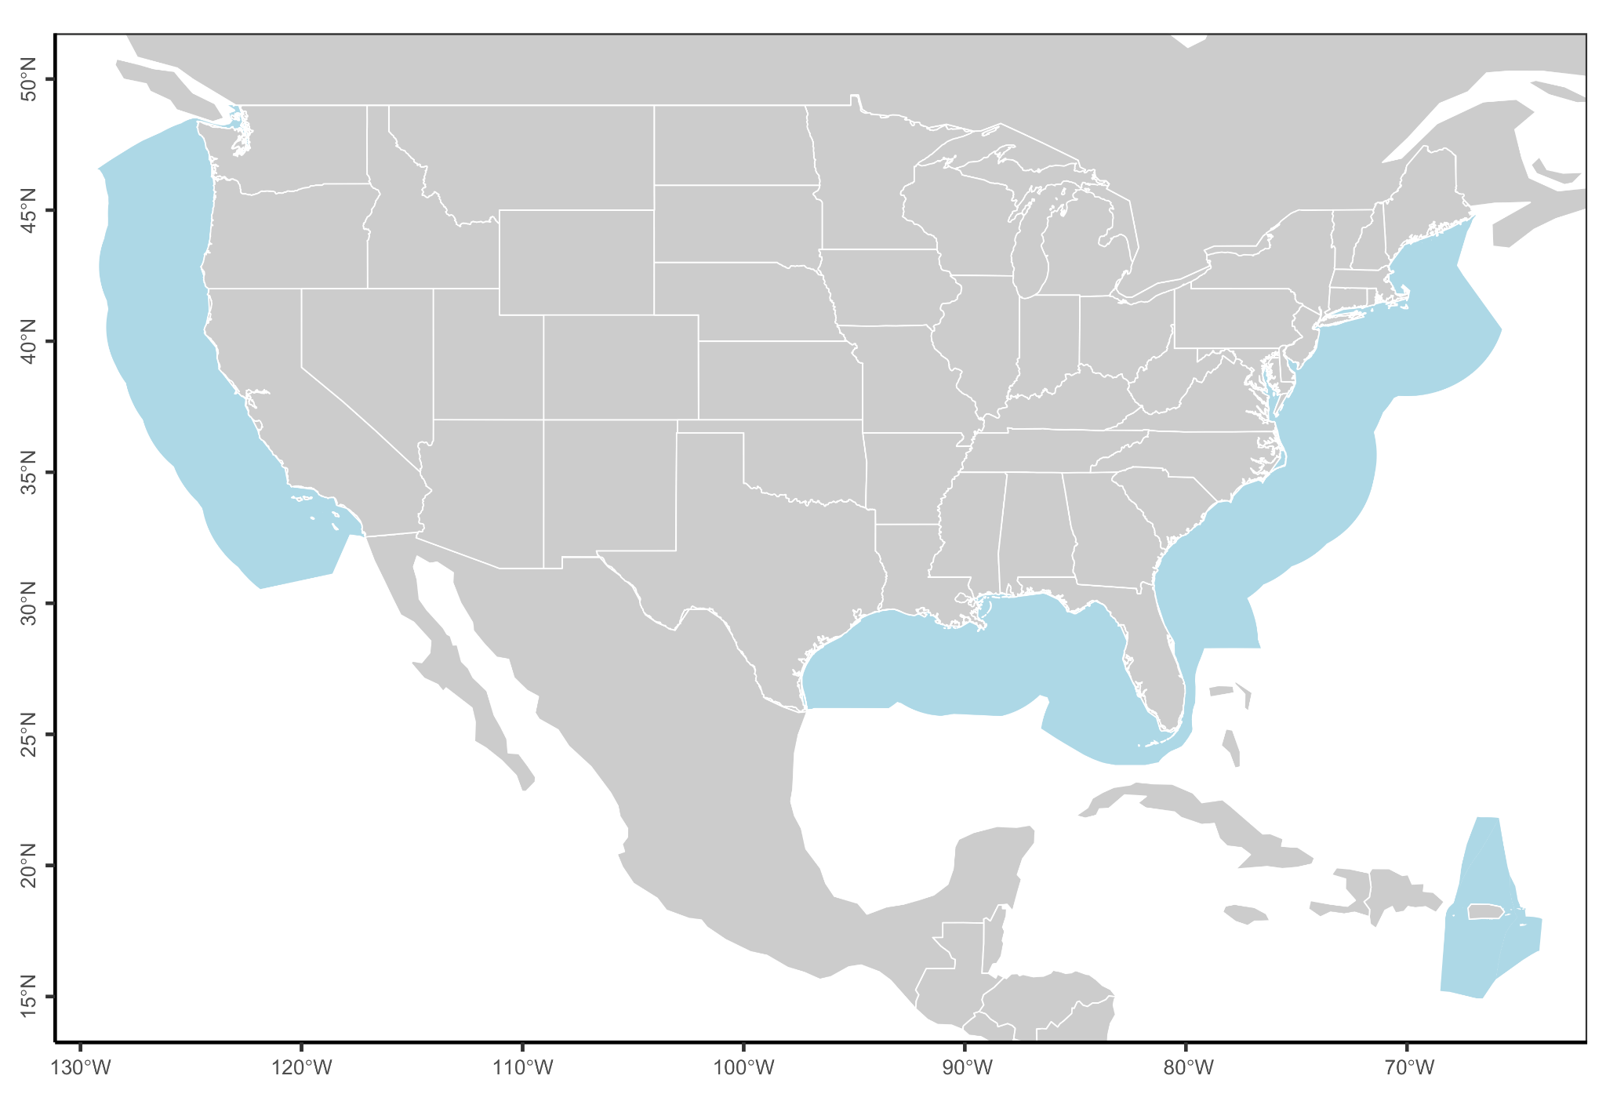**Figure 2.** Map and spatial allocations results.

##### 

##### 2.2.3 Sector allocations

The approach to allocating catch between sectors differs widely by region. In the South Atlantic, Gulf of Mexico, and Mid-Atlantic, which have large recreational fisheries, allocations between commercial and recreational sectors are done as a fixed percentage of the total allowable catch according to historical reference periods. In the Pacific and North Pacific, allocations to the recreational fishery usually done as set asides, where projections of expected recreational catch are removed from the total allowable catch before being allocated among commercial participants. This is similar to how catch for research, scientific surveys, or exempted fishing permit are done across councils. In the Caribbean, there are no explicit allocation, but the derivation of fixed catch limits using a historical reference period represents an implicit allocation. Among stocks whose sectoral allocations are done using a fixed percentage, the percentage varies widely as does the reference period.

### 

***Figure 3.*** *Sector-based allocation policies by regional Fishery Management Council. Panel* ***A*** *shows the percent of quota allocated to commercial and recreational fisheries by council and stock. Stocks are sorted in order of increasing allocations to recreational fisheries. The vertical dashed line indicates a 50:50 split. Panel* ***B*** *shows the reference period used to derive the allocation policy (lines) and the year in which the allocation policy went into effect (points). A few policies weigh the recent time period in addition to the selected reference time period.*

##### 2.2.4 Subsector allocations

##### 2.2.5 Catch share allocations

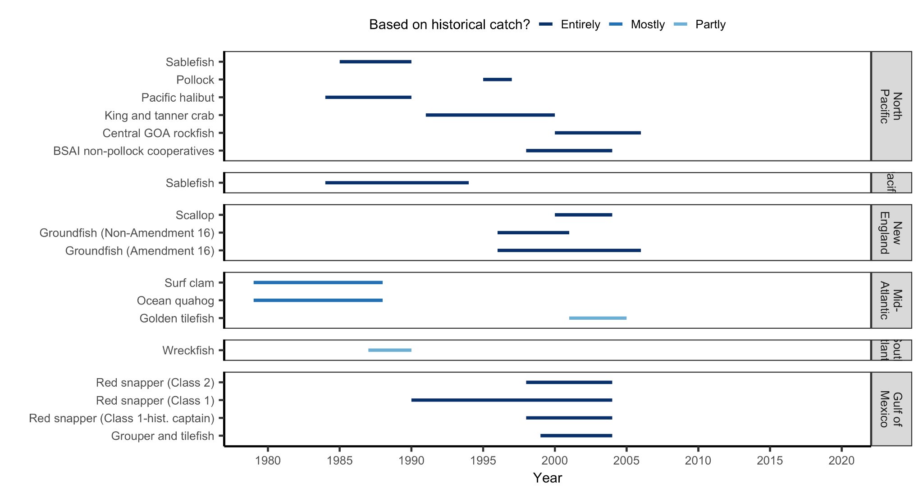**Figure 4.** Basis for catch share allocations documented by Morrison and Scott (2014).

##### 2.2.6 Seasonal allocations

The allocation of catch across seasons is used for only 34 stocks within 10 fishery management plans (**Figure X**). In general, seasonal allocations are motivated as a method to avoid catch limit overages and to curb a race to fish. An exception is the policy for Altnatic herring, which is motivated by XYZ. This rule is also interesting because its annual specification makes it inherently climate resilient.

Season allocations are also more common on the US East Coast (**Figure X**). On the West Coast, they are only used for Pacific sardine (Alosidae, *Sardinops sagax*) and select species managed under the BSAI and GOA Groundfish FMPs. On the East Coast, they are used for Northeast Multispecies FMP (trimesters), Northeast Small-Mesh (quarters), Northeast Skate complex (2 and 3 seasons for wing and bait fishery, respectively), Mid-Atlantic longfin inshore squid (Loliginidae, *Doryteuthis pealeii*) (trimesters) and scup (Sparidae, *Stenotomus chrysops*) (3 seasons), and South Atlantic king mackerel (Scombridae, *Scomberomorus cavalla*).

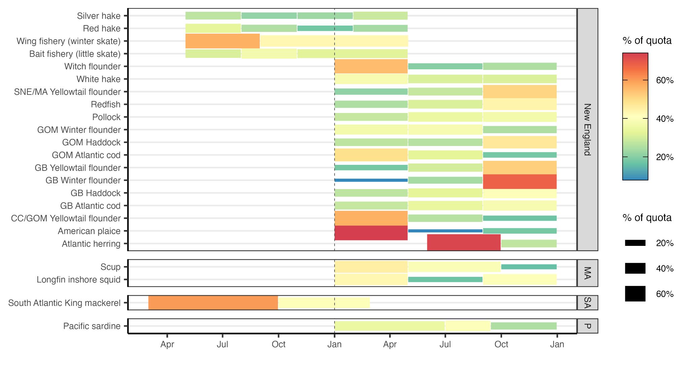

**Figure X.** Seasonal allocations of stocks by regional Fishery Management Council (MA=Mid-Atlantic, SA=South Atlantic, P=Pacific).

### 3. Allocation policies in international fisheries

#### 3.1 Australia

Australian allocation policies vary widely across subnational jurisdictions (states and territories). In 2010, the Australian Fisheries Managers Forum identified allocation as one the most important policy issues to address. The Fisheries Research and Development Corporation subsequently formed a working group to synthesize existing allocation policies and provide recommendations for reform. The working group report found that all jurisdictions except Western Australia and South Australia lacked clear policies for guiding allocation decisions [(Neville, 2012)](https://www.zotero.org/google-docs/?u0TW9a). In 2016, another government report concluded that *“the basis for allocation is often opaque, uncertain, and/or of questionable efficiency”* and that *“stated policy objectives include multiple and sometimes competing goals that often provide limited guidance on how judgements should be made”* [(Productivity Commission, 2016)](https://www.zotero.org/google-docs/?IS3btB). Since these reports, Queensland, New South Wales, and Northern Territory have established allocation policies but have yet to formally allocate any resources. Victoria and Tasmania have not yet developed an allocation policy [(Knuckey et al., 2019)](https://www.zotero.org/google-docs/?xS12x6). Existing allocations are between commercial, recreational, and Indigenous sectors, and have largely been set based on historical catch, despite the recognized importance of social, cultural, and economic values in making allocation decisions. A lack of data on Indigenous catch has led to a default allocation of 1% to Indigenous fishermen for most fisheries with sector allocations. However, the management plan for Goolwa pipi (*Latona deltoides,* Donacidae), a small saltwater clam, allows for trading between sectors, and the Indigenous allocation has reached as high as 25% of the catch. A 2021 review of Australian allocation policies found no examples of sub-sector allocations, which it described as being difficult to implement due to its controversial political nature [(McShane et al., 2021)](https://www.zotero.org/google-docs/?OCZFpq). In several jurisdictions, panels of independent experts and fishing industry representatives are convened to make or adjust allocation policies [(Mazur et al., 2020)](https://www.zotero.org/google-docs/?TU5kG2). These reviews can be triggered when there is sufficient stakeholder feedback, when a sector exceeds its allocation, or when the management plan is reviewed or changed substantially. If the panel determines a review is necessary based on the collected evidence, which includes information on historical catch, current allocation and management practices, and species biology, the panel makes recommendations to the minister of the relevant department, who makes the ultimate decision.

#### 3.2 New Zealand

The majority of New Zealand’s harvested marine species are managed through the Quota Management System (QMS), which is the national program under which catch limits are set and allocated amongst commercial, recreational, and customary fishery sectors [(Lock & Leslie, 2007)](https://www.zotero.org/google-docs/?i9vUxN). Customary fisheries are those managed by *tangata whenua* (people of the land with authority in a particular *rohe moana* [fishing area]) for non-commercial food gathering. The allocation between sectors varies by species [(Fisheries of New Zealand, 2024a)](https://www.zotero.org/google-docs/?3FS72K) but is generally dominated by the commercial sector (**Figure X**). Within the commercial sector, quota is allocated amongst commercial fishers that own Annual Catch Entitlements (ACEs) in the QMS catch share program. ACEs may be sold or leased but there are species-specific maximum holding limits to curtail aggregation, diversify ownership, and promote pathways for entering the fishery. There are also minimum holdings limits [(Fisheries of New Zealand, 2024b)](https://www.zotero.org/google-docs/?WjAcAT), which are presumably used to reduce complexity and encourage attainment, though we cannot find a stated motivation for these limits. Initial allocations were made based on each vessel owner’s catch history (i.e., owner’s choice of catch from the 1981/82, 82/83, or 83/84 season) and negotiations through a complex appeal process. When first introduced in 1986, these allocations were made as a fixed tonnage based on the Government’s belief that catch limits would only increase with improved management [(Lock & Leslie, 2007)](https://www.zotero.org/google-docs/?ItRMWH). However, in 1990, the near collapse of the orange roughy (Trachichthyidae, *Hoplostethus atlanticus*) fishery led the Government to convert shares to a fixed proportion based on quota owners holdings at the time of the transition. In the interim years, the Government bought back surplus quota when the sum of quota exceeded the catch limit, which was predictably expensive and inefficient. The Māori, the indigenous people of New Zealand, were excluded from the initial allocation process. The 1996 Fisheries Act determined that the Maori would be allocated 20% of the commercial quota for all new species added to the QMS and the remainder would be allocated to fishing permit holders based on their catch history. In 2022, the Maori were reported to own 33% of commercial catch (47% by value) in 2022 and 100% of the customary catch [(Hudson, 2022)](https://www.zotero.org/google-docs/?9OGYdn).

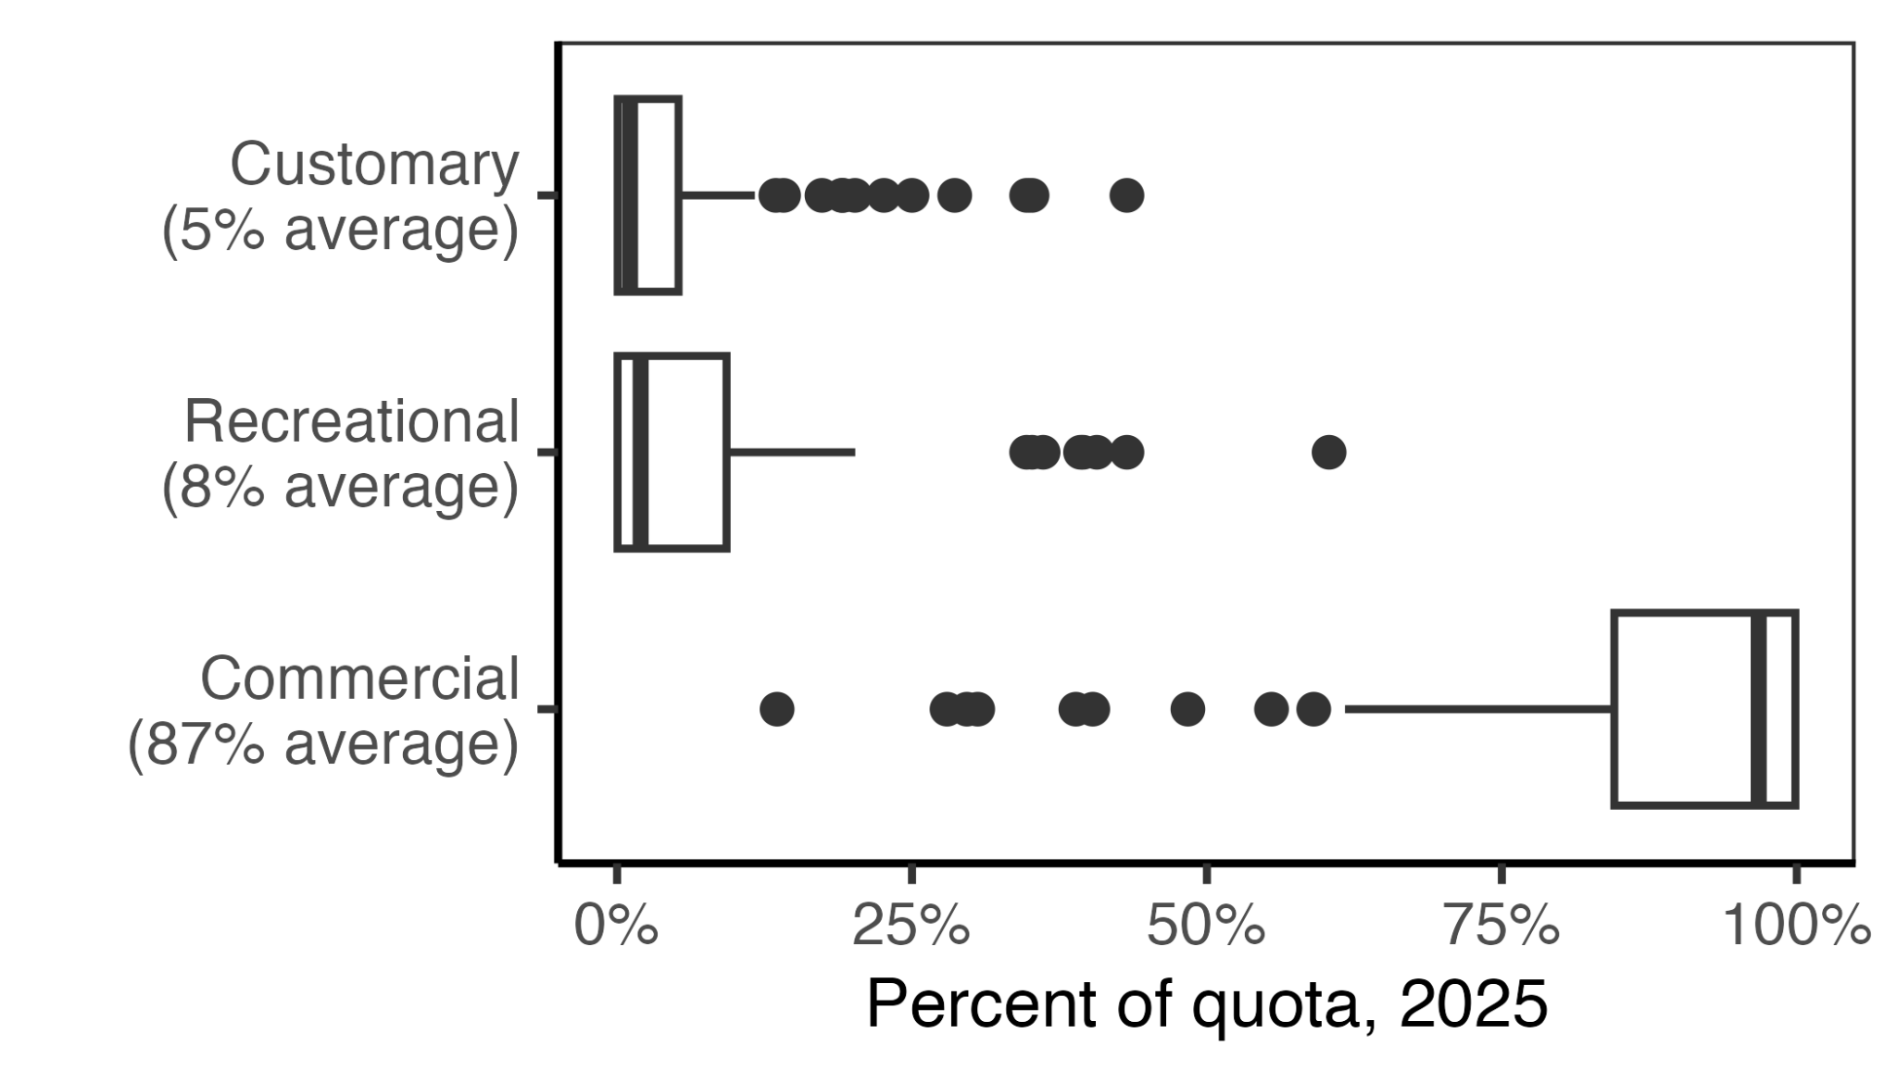

***Figure X.*** *Quota allocation percentages among sectors for the 98 species managed within New Zealand’s Quota Management System in 2025* [*(Fisheries of New Zealand, 2024a)*](https://www.zotero.org/google-docs/?NNXLkC)*. In the boxplots, the solid line indicates the median, the box indicates the interquartile range (IQR; 25th to 75th percentiles), the whiskers indicate 1.5 times the IQR, and points indicate outliers.*

#### 3.3 Pacific Island skipjack tuna

The Parties to the Nauru Agreement (PNA) [(PNA Tuna, 2010)](https://www.zotero.org/google-docs/?FKhFpp), which governs the management of skipjack tuna (Scombridae, *Katsuwonus pelamis*) in nine Pacific Island countries, has been heralded as one of the best climate-adaptive spatial allocation systems [(Aqorau et al., 2018)](https://www.zotero.org/google-docs/?W7pX9F). The PNA’s “vessel day scheme” (VDS) [(PNA Tuna, 2011)](https://www.zotero.org/google-docs/?pmAXlQ) was explicitly developed to cooperatively manage this highly migratory species as it shifts its distribution across the waters of PNA members due to changing oceanographic conditions. The VDS is a “cap and trade” system that sets the total annual purse-seine fishing effort at ~45,000 days and allocates these days to member countries based on the area of their Exclusive Economic Zones (EEZs) and the preceding 7-8 years of catch. Importantly, the VDS also provides a pathway for PNA members to trade quota in response to El Niño Southern Southern Oscillation (ENSO). During the La Niña phase of ENSO, the catch is concentrated in the west, whereas during the La Niña phase, the catch is concentrated in the east [(Lehodey et al., 1997)](https://www.zotero.org/google-docs/?h4x4Js). With trading, the VDS allows countries to buy fishing days when tuna are located in their region and sell fishing days when tuna are located elsewhere. In this way, the VDS allows member countries to profit regardless of where skipjack tuna are caught that year. This system is expected to provide resilience as skipjack tuna shift east due to directional climate change [(Bell et al., 2013)](https://www.zotero.org/google-docs/?KfK4gG). The expectation is that, over time, PNA countries in the east will gradually receive greater allocations as their catch history increases relative to countries in the west, and countries in the west will be compensated for these directional losses [(Aqorau et al., 2018)](https://www.zotero.org/google-docs/?J6eAp6).

### 4. Best practices for climate-adaptive allocation policies

Based on our systematic review of U.S. allocation policies and informal review of international policies and the scientific literature, we identified eight practices for implementing or enhancing the adaptive management of quota allocation policies (**Figure X**). Adaptive management, which periodically reviews and updates management strategies to ensure that management objectives are being met [(Walters & Hilborn, 1976)](https://www.zotero.org/google-docs/?FCH2ZC), provides inherent climate resilience by ensuring that management is responsive to changing conditions [(Bahri et al., 2021)](https://www.zotero.org/google-docs/?De7Wq7). The practices are to: (1) define clear and measurable management objectives; (2) conduct regular reviews of allocation policies; (3) define and collect data required to assess and adjust allocation policies; (4) balance historical and contemporary resource access in setting allocations; (5) facilitate quota transfers between regions, sectors, and individuals; (6) ensure opportunities for new entrants; (7) allocate quota for research and experimentation; and (8) reduce impacts of changes to allocation policies on stakeholders. We detail these recommendations in the sections below.

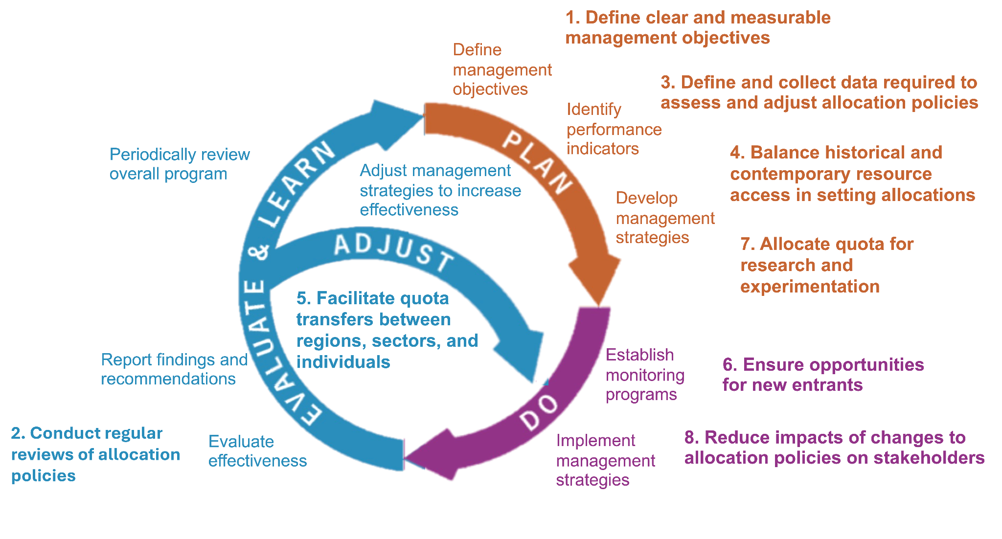

***Figure 5.*** *A conceptual diagram illustrating the eight practices (bolded text) for enhancing the adaptive management of quota allocation policies.*

#### 4.1 Define clear and measurable management objectives

The adaptive management of quota allocation policies depends on the definition of clear and measurable management objectives [(Plummer et al., 2012)](https://www.zotero.org/google-docs/?iD9epm). Without these, managers will be unable to track whether objectives are being met or determine if adjustments are necessary, which is especially problematic as climate-driven changes in resource availability accelerate the need for policy modifications. We recommend that each Fishery Management Plan define allocation objectives, discuss tradeoffs between competing objectives [(Heen et al., 2014; Mardle et al., 2000)](https://www.zotero.org/google-docs/?fRHQHr), and identify data sources that can be used to monitor progress towards objectives (see *section 4.3*). Adaptive management of allocation policies provides inherent climate resilience by ensuring that policies are regularly revisited to ensure that they are achieving their objectives as both oceanographic and socioeconomic conditions change. There may also be opportunities to explicitly incorporate climate change into allocation policy objectives. For example, allocation could be used as as a tool for mitigating the negative impacts of climate change, especially on vulnerable communities, by allocating the most climate-vulnerable communities [(Colburn et al., 2016; Himes-Cornell & Kasperski, 2015; Koehn et al., 2022)](https://www.zotero.org/google-docs/?9XLhJ3) more quota than their historical share. While allocations have historically sought to maintain “horizontal equity” where allocations are proportional to historical access, the Magnuson-Stevens Act and associated guidelines leave the door open for alternative definitions of equity [(W. Morrison, 2016b)](https://www.zotero.org/google-docs/?30ZW58). Instead, managers could set goals for “vertical equity” and use allocation as a tool for compensating communities disadvantaged by historical allocations or by the impacts of contemporary or future climate change [(Kourantidou et al., 2021)](https://www.zotero.org/google-docs/?FjcjKN).

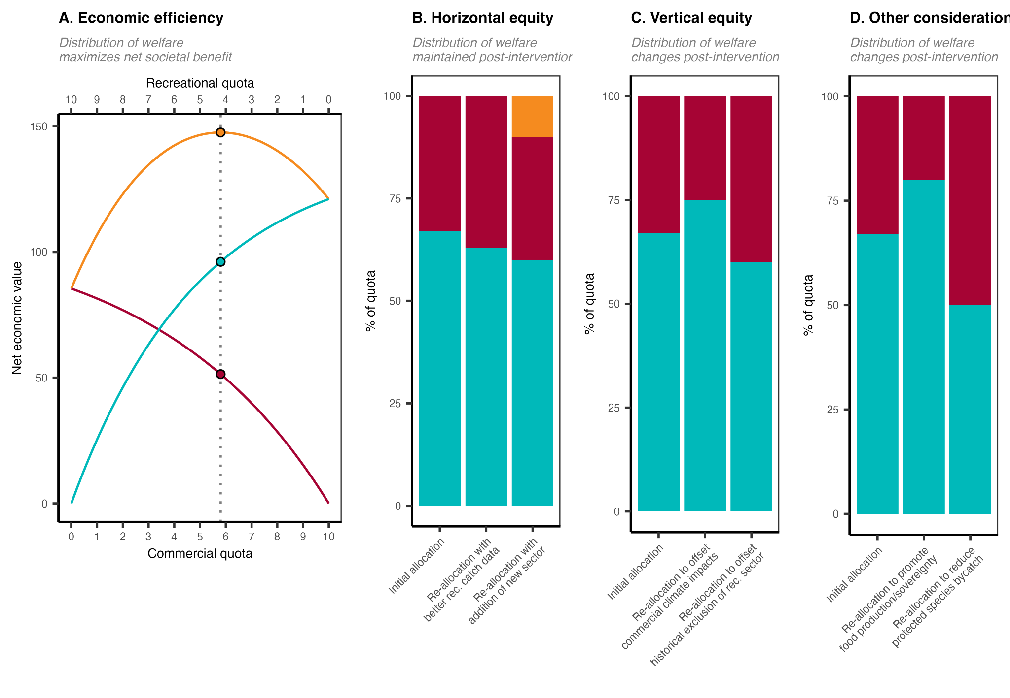

***Figure 6.*** *An illustration of alternative conceptualizations of equity in quota allocation policies. Panel* ***A*** *illustrates an allocation policy that seeks to optimize economic efficiency by maximizing the net economic benefits of commercial and recreational fisheries. The optimal policy is marked by the vertical dotted line. Panel* ***B*** *illustrates a suite of allocation policies that seek to maintain “horizontal equity” whereby the distribution of welfare remains proportional to historical levels. Column 1 shows the initial allocation based on historical catch. Column 2 illustrates a scenario in which the policy is updated with improved estimates of historical recreational catches. Although it results in a different distribution of welfare relative to the initial policy, it is motivated by the same goals (but uses better data) and is therefore still an example of horizontal equity. Column 3 illustrates a scenario in which a historically omitted subsistence sector is given access. The losses in allocation to the original sectors are proportional; thus, horizontal equity is maintained. Panel* ***C*** *illustrates a suite of allocation policies that seek to achieve “vertical equity” whereby the distribution of welfare changes after an intervention in a way considered more fair. This could be to compensate communities disadvantaged by historical allocations (column 2) or by the impacts of contemporary or future climate change (column 3). Managers may also adjust allocation policies to achieve other fisheries objectives such as promoting food production* *and sovereignty by prioritizing commercial fishing or reducing bycatch of protected species by prioritizing more selective recreational fisheries. Although these adjustments change the distribution of welfare, they are not motivated by equity and fairness between sectors (though they do relate to broader societal concepts of fairness) and do not fully classify as vertical equity. We illustrate these concepts using sector allocations as the example but all these concepts apply to any allocation between harvesting entities (states, subsectors, individuals, etc).*

#### 4.2 Conduct regular reviews of allocation policies

Adaptive management requires the periodic review of policies to ensure that objectives are being met or if adjustments are needed. Thus, managers must develop a clear procedure for determining when to review allocation policies, whether to adjust them, and how to make adjustments when necessary. A number of NOAA policy documents provide useful guidance on scheduling and conducting allocation policy reviews [(W. Morrison, 2016b, 2017b, 2017c)](https://www.zotero.org/google-docs/?Edz6LK) but implementation of this guidance has lagged [(US GAO, 2020)](https://www.zotero.org/google-docs/?8mh0IN). These guidelines suggest that reviews could be scheduled at regular intervals, prompted by stakeholder feedback, or triggered by a tracked performance indicator. Managers could blend approaches to balance the advantages and disadvantages associated with each approach. For example, allocation reviews require time and resources that compete with other Council responsibilities [(PFMC, 2023)](https://www.zotero.org/google-docs/?cMXHdN), and regular reviews should not be scheduled too frequently. Instead, they could operate as a failsafe in case a review is not triggered by either stakeholder input or a tracked performance indicator within a set timeframe. The ability for stakeholder feedback to prompt allocation reviews strengthens inclusive, participatory, and transparent governance, which are central to climate-resilient fisheries management [(Mason et al., 2022)](https://www.zotero.org/google-docs/?vp2KJJ); however, to avoid taking on allocation reviews too frequently, clear criteria for stakeholder-prompted reviews must be established. Furthermore, some stakeholder groups may have better representation than others, underscoring the value of regular or indicator-triggered reviews to ensure equity and fairness for under-resourced groups. Triggering reviews based on a tracked performance indicator is a compelling approach because it compels managers to define clear and measurable management objectives. The indicator could be economic (e.g., cost-benefit, economic impact, or economic efficiency analyses; [(Edwards, 1990; Plummer et al., 2012)](https://www.zotero.org/google-docs/?oRGL7H)), social (e.g., metrics of resilience, vulnerability, or well-being; [(Jepson & Colburn, 2013)](https://www.zotero.org/google-docs/?MNRx0j)), ecological (e.g., changes in stock status, increases in discards, changes in species distribution, etc.), or a combination, noting that National Standard 5 prevents allocation decisions from being made based on economics alone [(§ 600.330 National Standard 5—Efficiency, 1998)](https://www.zotero.org/google-docs/?NXdUm5).

#### 4.3 Define and collect data required to assess and adjust allocation policies

The adaptive management process hinges on the definition and evaluation of indicators for tracking management performance and for determining when adjustments need to be made to management strategies or even management objectives [(Walters, 2007)](https://www.zotero.org/google-docs/?MPKGbJ). This requires resources to be directed to data collection and analysis that can inform whether allocations are achieving their objectives and subsequently guide revisions if they are not. The following list of potential indicators is not comprehensive but illustrates some of the data types that may be useful for tracking performance. First, catch reporting and monitoring should be specific enough to evaluate attainment (i.e., the percent of the allocation caught annually) among the entities allocated catch. If rigorous catch monitoring is established and a specific entity (e.g., state, sector, subsector, etc.) is consistently under its quota, then reallocation of that quota to another entity, especially if that entity consistently meets its quota, may be justified. Second, reliable estimates of discards may be necessary to determine whether the current allocation is using the resource efficiently and minimizing waste and ecosystem impacts. Third, demographic information on fishery participants throughout the supply chain – ranging from owners, captains, crew, processors, and dealers – especially on vulnerable groups, is necessary for evaluating equity and fairness [(NAS, 2024)](https://www.zotero.org/google-docs/?DkkTmi). Fourth, knowledge of species distributions, which may require coordination across states, Councils, and even nations, will involve collection, curation, and analysis of fisheries-independent survey data. Finally, if managers seek to consider climate vulnerability of a species, habitat impacts of a gear, protected species bycatch, or other factors, data must be collected to inform these judgements. Ultimately, the data collected should be aligned with management objectives; a management objective may prove ineffective if it is not measurable or is not actively measured.

#### 4.4 Balance historical and contemporary resource access in setting allocations

The adaptation of allocation policies to climate-driven changes in resource distribution will require weighing both historical and contemporary access to resources. The tendency for current allocation policies to interpret equity as the maintenance of historical access is unlikely to meet fisheries objectives as stocks shift in their availability. A failure to adjust allocations in response to these shifts could undermine (1) fairness and equity, by preventing those with growing local fisheries from benefiting from these gains, (2) efficiency, by requiring boats to travel further to access the resource, which increases costs, safety concerns, and carbon emissions [(Papaioannou et al., 2021; Scherrer et al., 2024)](https://www.zotero.org/google-docs/?5CpIwu); and (3) conservation, by promoting local depletion if quota holders continue to fish in areas at the trailing edge of a shifting distribution [(Pinsky & Fogarty, 2012)](https://www.zotero.org/google-docs/?LqCJwN). However, at the other end of the spectrum, fully adjusting allocation policies in response to contemporary or projected changes in resource distributions could also introduce equity challenges by reducing access for stakeholders who have historically relied on the resource [(Palacios-Abrantes et al., 2023)](https://www.zotero.org/google-docs/?rMVnlz). Thus, adjusting allocations by weighing both historical and contemporary resource access may present a useful compromise, especially when quota is transferable (see *section 4.5*). This can be achieved by calculating allocation percentages by weighing historical landings with recent landings (e.g., sector allocations in the South Atlantic snapper-grouper fishery) or with current biomass distribution as estimated from either a survey (e.g., area allocations in the Gulf of Alaska pollock fishery) or an assessment model (e.g., state allocations in the Mid-Atlantic black sea bass commercial fishery). Among these approaches, we recommend weighing current conditions based on the distribution of the resource, as the distribution of the catch lags behind resource shifts and is inherently limited by existing allocation policies and management regulations [(Pinsky & Fogarty, 2012)](https://www.zotero.org/google-docs/?uGVe7Q). Additionally, we recommend quantifying distribution shifts using fisheries-independent surveys given the high temporal and spatial resolution of these surveys [(Maureaud et al., 2024)](https://www.zotero.org/google-docs/?kxPKU6) compared to stock assessments, which are updated less regularly (e.g., every 2-10 years; [(Neubauer et al., 2018)](https://www.zotero.org/google-docs/?yKE9Jp)) and represent coarse spatial structure. Ultimately, the weight assigned to historical and contemporary access is a policy decision that should be explicitly linked to policy objectives, but in general, we recommend that historical access be favored for static stocks and that contemporary access be favored for stocks shifting more quickly. Some scientists and managers have explored the viability of ‘dynamic allocation’ for quickly shifting stocks – an automated process for allocation incorporating both current distributions and historical catch (Vogel et al. 2024).

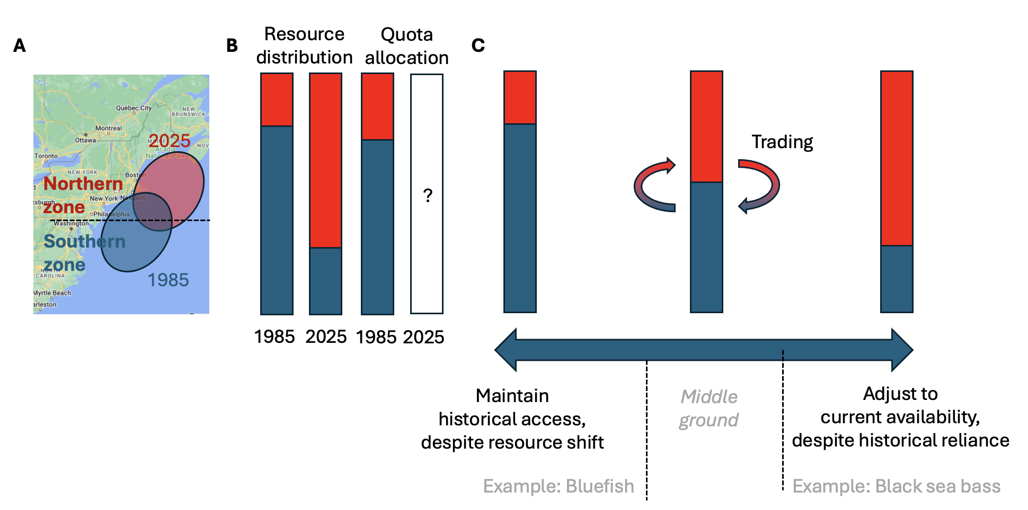

***Figure 7.*** *A conceptual schematic illustrating the spectrum of allocation options available to managers as stocks shift distributions (and their availability to fisheries) under climate change. Panel* ***A*** *illustrates the shift in distribution of hypothetical stock from 1985 to 2025 relative to its management jurisdictions. Panel* ***B*** *illustrates the proportional distribution of the resource between the two management zones in 1985 and 2025. The allocation of quota between the zones roughly matches the 1985 distribution because it was established based on 1980-1985 catch distribution. Managers must now decide whether and how to adjust the quota allocation given this climate-driven shift in distribution. Panel* ***C*** *illustrates the spectrum of options available to managers. On one end of the spectrum, they could maintain historical access despite the resource shift. This protects historical access for southern zone fishermen but introduces inefficiencies, risks local depletion, and is unfair to northern zone fishermen. On the other end of the spectrum, they could fully adjust to current resource distribution. This is efficient and aligned with conservation goals but does not protect historical dependence. As a result, managers may wish to find a middle ground. Examples of how to empirically set this middleground are shown. Furthermore, allowing trading between zones provides a mechanism for northern fishers to gain access and for southern fishers to be compensated for lost access.*

#### 4.5 Facilitate quota transfers between regions, sectors, and individuals

The ability for quota owners to transfer quota access rights – either temporarily through leasing or permanently through sale – provides flexibility for fishermen to adapt to climate change and other shocks [(Tokunaga et al., 2023)](https://www.zotero.org/google-docs/?yBsAze). The temporary transfer of quota access through leasing provides in-season flexibility and the ability for fishermen to rapidly respond to changes in ways that are more self-governed. The permanent transfer of quota access provides a mechanism for fishermen who have lost access to a resource to be compensated and provides capital necessary for adapting to this loss of livelihood provisioning. While the ability to transfer quota between individuals is a feature of most catch share programs, the ability to transfer quota between sectors and states is less common, which presents a key opportunity to enhance climate resilience. As one example, limited ability to transfer or lease quota between the at-sea and inshore Bering Sea pollock sector have limited the fisheries ability to respond to changes in species distributions, bycatch management, and market dynamics (Criddle and Strong 2013). These programs could be modeled after Mid-Atlantic bluefish (*Pomatomus saltatrix*, Pomatomidae), which allows for transfers between the commercial and recreational sectors, and Mid-Atlantic black sea bass (*Centropristis striata*, Serranidae) and summer flounder (*Paralichthys dentatus*, Paralichthyidae), which allows for transfers between states. A key risk in allowing transfers is the consolidation of quota among a few individual entities; however, this adverse outcome can be curbed through the use of quota caps that limit the percent of quota that can be possessed by an individual entity [(Brinson & Thunberg, 2016)](https://www.zotero.org/google-docs/?0idAfu). This is consistent with National Standard 4, which requires that “*no particular individual, corporation, or other entity acquires an excessive share of such privileges”* [(§ 600.325 National Standard 4—Allocations, 1998)](https://www.zotero.org/google-docs/?2yFL8n). The transferability of quota also serves to: (1) increase economic efficiency, by ensuring that quota aggregates among those with easiest access to the resource; (2) promote conservation, by ensuring that fishing effort occurs in proportion to biomass, thereby avoiding the local depletion that could occur if quota remained tied to areas with declining abundance [(Pinsky & Fogarty, 2012)](https://www.zotero.org/google-docs/?fQOrKn); and (3) provide a mechanism for fishermen losing access to be be directly compensated and for fishermen gaining access to capitalize on emerging resources, which could compensate for climate-driven losses in other fisheries in their portfolio [(Cline et al., 2017; Samhouri et al., 2024)](https://www.zotero.org/google-docs/?vRg4tj). Finally, the ability to transfer quota is aligned with resilience principles that encourage self-governance and flexibility [(Mason et al., 2022)](https://www.zotero.org/google-docs/?VSN1dp).

#### 4.6 Ensure opportunities for new entrants

Any policy that allocates natural resources among harvesters should consider new entrants seeking to gain access to the resource [(Cox, 2009)](https://www.zotero.org/google-docs/?hc6krS). The initial capital required to obtain commercial fishing permits, quota, gear, and/or vessels limits new participants (Cullenberg et al. 2017). These barriers are particularly steep in fisheries with catch shares or other forms of limited entry programs, and have played a role in the ‘graying of the fleet,’ or the increased average age of commercial fishermen (Cramer et al. 2018). Climate change is likely to exacerbate the new entrant problem as climate-driven shifts in the distribution of fish and invertebrates will make the resource available to new regions, sectors, and individuals [(Pinsky et al., 2018)](https://www.zotero.org/google-docs/?oS5aBz). A pathway for providing access to these new participants is critical for increasing economic efficiency, perceptions of fairness, and the stability of allocation decisions [(Cox, 2009)](https://www.zotero.org/google-docs/?D8vDPF). Furthermore, it could improve the resilience of fishers to climate change by allowing catch from emerging fisheries to compensate for losses from declining fisheries [(Cline et al., 2017; Samhouri et al., 2024)](https://www.zotero.org/google-docs/?iR8SxI). Access for new entrants could occur organically through quota transfers (see *section 4.5*) and could be further catalyzed through set asides reserved for new entrants or through quota and/or permit banks that ease access for new participants. For example, the Pacific Council sets aside quota from the groundfish catch share program in a “public trust pool” that can be used to support conservation, new entrants, community stability, or to compensate for unintended consequences of the catch share program [(PFMC & NMFS, 2010)](https://www.zotero.org/google-docs/?OCXABC). Unfortunately, the program has yet to be used, which limits insights into both the benefits and pitfalls of new entrant set asides [(Nayani & Warlick, 2018)](https://www.zotero.org/google-docs/?HOV4Lh). The leasing of quota or permits to new participants through fisheries trusts (banks), potentially at rates lower than they would receive from a traditional owner, can help new entrants gain experience and capital before buying quota or permits themselves [(Kauer et al., 2024)](https://www.zotero.org/google-docs/?CBUG8k). For example, in 2010, the Maine Department of Marine Resources purchased eleven Federal Northeast Multispecies Permits, which it leases to fishermen through the Maine Groundfish Permit Bank [(Maine DMR, 2022)](https://www.zotero.org/google-docs/?hqjimN). Other examples include the Alaska Community Quota Entities, which lease groundfish and crab quota to catch share members [(NPFMC, 2016)](https://www.zotero.org/google-docs/?QEAL8X) and the Monterey Bay Fisheries Trust, which leases groundfish quota at reduced rates to local fishermen [(Kauer et al., 2024)](https://www.zotero.org/google-docs/?B6pP12).

#### 4.7 Allocate quota for research and experimentation

The allocation of quota towards programs that support research and experimentation could incentivize adaptive innovation in response to climate change. This could include the reservation of quota for existing programs such as “research set asides” (RSAs) or for “exempted fishing permits” (EFPs). Research set asides, which have only been used by the New England and Mid-Atlantic Councils, represent a portion of quota that is set aside for vessels engaged in scientific research. The set-aside quota is awarded through a competitive grant process and the sale of the associated catch funds the research and compensates the vessels supporting the research [(NOAA, 2024)](https://www.zotero.org/google-docs/?0GOTq2). These programs have been especially successful for high value stocks such as scallops and monkfish in New England (Vogel et al. 2024). The program in the Mid-Atlantic lasted from 2002-2016 and funded 41 projects totalling $16 million in value [(MAFMC, 2024)](https://www.zotero.org/google-docs/?FyFHjq) on issues ranging from X to X. The program was discontinued due to concerns of misuse and concerns that the quality of the science did not justify the costs. While some projects, such as the trawl survey conducted by the Northeast Area Monitoring and Assessment Program, generated data used in management, many other projects failed scientific review post-completion, raising concerns about proposal vetting and project oversight [(MAFMC, 2024)](https://www.zotero.org/google-docs/?bCB4li). Thus, expansion of the RSA program would require reforms that address these issues. Exempted fishing permits are a national program supported by all of the regional Councils [(NMFS, 1996)](https://www.zotero.org/google-docs/?ce4y7t). These permits allow fishermen who partner with scientists to conduct cooperative research to fish in ways that may not otherwise be permitted. The dedicated allocation of quota to these programs could incentivise research into adaptive actions that promote climate resilience [(Bonito et al., 2022)](https://www.zotero.org/google-docs/?HLLaY1). For example, research could reveal methods for targeting emerging fisheries, avoiding bycatch problems, generating more reliable indices of abundance that support better management, marketing new products, or making gears more efficient [(Free et al., 2023)](https://www.zotero.org/google-docs/?b8198F).

#### 4.8 Reduce impacts of changes to allocation policies on stakeholders

The adjustment of quota allocation policies in response to climate change and other socioecological factors will inevitably result in a set of “winners” who gain quota and “losers” who forfeit quota. A number of actions can be taken to minimize the socioeconomic impacts to communities losing access to quota when allocation policies change. First, the gradual “phase in” of changes to allocation policies gives communities losing access to quota time to adapt. Phased allocation changes have been pioneered by the Mid-Atlantic Council, which, for example, used a 7-year phase-in period to reallocate commercial bluefish (*Pomatomus saltatrix*, Pomatomidae) quota among fourteen East Coast states [(MAFMC, 2021)](https://www.zotero.org/google-docs/?9tCouD). Second, the preservation of some minimal amount of quota through a “*de minimis*” allocation guarantees at least some level of access for historical participants when allocations are dynamically updated based on the current abundance or distribution of resources. *De minimis* allocations have been used by the Mid-Atlantic Council to preserve minimum levels of commercial access to bluefish by states [(MAFMC, 2021)](https://www.zotero.org/google-docs/?ZLEIVy) and have been used by the Pacific Council to preserve minimum levels of access to South of Cape Falcon Coho salmon (*Oncorhynchus kisutch*, Salmonidae) for the recreational sector when biomass fluctuates [(PFMC, 2021)](https://www.zotero.org/google-docs/?TtNNkT). Such policies could preserve access if the adjustment of spatial quota allocations in response to survey-based (e.g., New England Transboundary Management Guidance Committee-managed stocks) or model-based (e.g., Mid-Atlantic black sea bass) estimates of spatial distribution became more common. Finally, the redistribution of allocation through the sale of quota rather than through policy adjustments allows those losing quota to be directly compensated, which provides capital necessary for adaptation [(Mason et al., 2022)](https://www.zotero.org/google-docs/?gySZwE).

### 5. Priority fisheries for allocation policy reforms

#### 5.1 Methods

We used information on the climate vulnerability of stocks to identify Fishery Management Plans (FMPs) that are high priorities for climate-adaptive policy reforms. We used information from two complementary sources: (1) expert-opinion-based assessments of species-specific climate vulnerability from regional Climate Vulnerability Assessments (CVAs) [(W. E. Morrison et al., 2015, 2016; NOAA Fisheries, 2024)](https://www.zotero.org/google-docs/?wx6ih1) and (2) model-based projections of regional species-specific range shifts under climate change [(Morley et al., 2018)](https://www.zotero.org/google-docs/?M7N2RP). While the CVAs provide general insights into the full range of potential climate impacts, the range shift projections provide more detailed insights into the magnitude of future range shifts specifically. The CVAs also cover a wider range of species, as the range shift projections were only generated for species that are well-sampled by regional bottom trawl surveys [(Morley et al., 2018)](https://www.zotero.org/google-docs/?dHd0rP).

CVAs leverage expert knowledge to assess the vulnerability of species to climate change based on their exposure to projected changes in the environment (e.g., warming oceans) and their sensitivity to these changes based on their life history characteristics (e.g., reproductive rates, diet etc). Ultimately, species are classified as having “very high”, “high”, “moderate”, or “low” exposure, sensitivity, and vulnerability to climate change. We assembled CVA designations for all species in the following regions: Northeast [(Hare et al., 2016)](https://www.zotero.org/google-docs/?SM2SBp), South Atlantic [(Burton et al., 2023)](https://www.zotero.org/google-docs/?deJN47), Gulf of Mexico [(Quinlan et al., 2023)](https://www.zotero.org/google-docs/?ZFqGRm), Pacific [(McClure et al., 2023)](https://www.zotero.org/google-docs/?6tqjGq), North Pacific [(Spencer et al., 2019)](https://www.zotero.org/google-docs/?wh86PA), and Western Pacific [(Giddens et al., 2022)](https://www.zotero.org/google-docs/?CeFpFh). There is no CVA for the Caribbean region and the CVA for the Northeast region does not differentiate between stocks managed by the New England and Mid-Atlantic Fishery Management Councils.

We used species projections from Morley et al. (2018) to identify federal stocks likely to undergo climate-driven range shifts by the end of the century. These projections, based on historical species distributions and general circulation climate models, estimate range shifts of fish and invertebrates effectively sampled by trawl gear under both low and high greenhouse gas emission scenarios (relative concentration pathways 2.6 and 8.5). The range shifts were calculated by measuring the changes in the locations of species' weighted centroids between the present and the end of the 21st century (Morley et al. 2018). We matched these species projections to federal fishery stocks. Since the certainty of the predicted range shifts varied across species, we only matched stocks to region-specific projections for species with medium and high certainty estimates. The matched stocks were then grouped by FMP. Only stocks made up of species explicitly stated in the FMP were included (i.e. the Shark complex managed through the Groundfish of the Bering Sea and Aleutian Islands FMP was not included). We then identified stocks with spatial allocation policies (e.g., country, state, region) that are projected to experience significant shifts by the end of the century, as area-based allocation policies are most directly impacted by shifting species distributions (Palacios-Abrantes et al. 2023).

#### 5.2 Results

##### 5.2.1. CVA analysis

Based on the CVA analysis, the high priority FMPs for climate-adaptive policy reform by Fishery Management Council (FMC) are as follows:

* **New England:** The Atlantic Sea Scallops, Northeast Multispecies Fishery, and Northeast Skate Complex FMPs are the highest priority FMPs for climate-adaptive allocation policy reform in the New England region. Although the Atlantic Salmon FMP exhibits high climate vulnerability, there are no allocations in this fishery since catch is prohibited. The remaining FMPs all include species with low climate vulnerability.
* **Mid-Atlantic:** The Summer Flounder, Scup, and Black Sea Bass FMP is the highest priority FMP for climate-adaptive policy reform in the Mid-Atlantic region because of its high vulnerability and complex allocation system. The Atlantic Surfclam and Ocean Quahog FMP and Tilefish FMP are of secondarily high priority because they are also climate vulnerable but have less complex allocation systems.
* **South Atlantic:** The South Atlantic region is the highest priority region for climate-adaptive allocation policy reform given the high climate vulnerability of nearly all of its FMPs. Only the Dolphin-Wahoo FMP exhibits moderate climate vulnerability.
* **Gulf of Mexico:** The Reef Fish Resources FMP is the highest priority FMP for climate-adaptive allocation policy reform in the Gulf of Mexico region given the elevated vulnerability of the FMP relative to the Shrimp and Red Drum FMPs.
* **Pacific:** The Pacific Salmon FMP is the highest priority FMP for allocation policy reform in the Pacific region followed by the Pacific Groundfish and Highly Migratory Species FMPs. The Coastal Pelagic Species FMP exhibits the least climate vulnerability of the region’s FMPs.
* **North Pacific:** The North Pacific exhibits the least climate vulnerability of the evaluated region’s but a large number of species managed within its FMPs have not been assessed for their climate vulnerability. However, the primary target species are represented in these assessments. Of its FMPs, the Groundfish and Crab FMPs are the highest priority for climate-adaptive allocation policy reforms.
* Western Pacific: Like the North Pacific region, the Western Pacific region also manages a large number of species that have not been assessed for their climate vulnerability. Based on the species that have been assessed, the Pacific Pelagic Fisheries FMP (which overlaps with the Pacific’s Highly Migratory Species FMP), exhibits the greatest climate vulnerability and is therefore the highest priority candidate for allocation policy reform. The remaining FMPs exhibit roughly equivalent climate vulnerability.

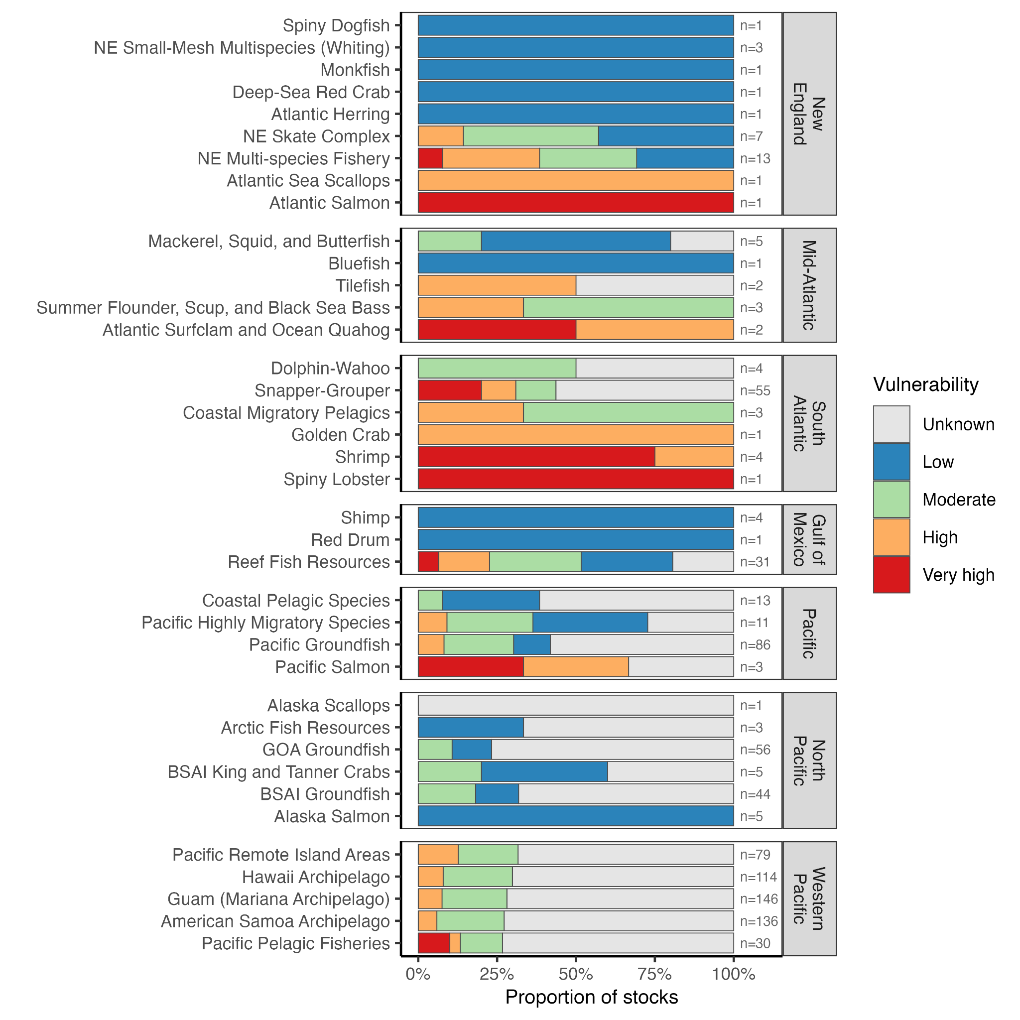

***Figure X.*** *The climate vulnerability of targeted species managed by each fishery management plan (FMPs) based on regional Climate Vulnerability Assessments (CVAs). FMPs are grouped by Fishery Management Council and are ordered by the average climate vulnerability of target species managed by the FMP. The number of species in the FMP is printed in gray text.*

##### 5.2.2. Projection analysis

Medium or high certainty regional projections were available for 102 of the 1031 unique taxa/regions represented by federal stocks managed by NPFMC, PFMC, NEFMC, SAFMC, MAFMC, and GFMC. Projections were based on fisheries independent bottom trawl survey data, which are not available in the jurisdictions of the WPFMC or CFMC. Based on the range shift projection analysis, the high priority FMPs for climate-adaptive policy reform by Fishery Management Council (FMC) are as follows:

* **North Pacific:** Species managed by theNPFMC are expected to undergo moderate shifts (20 - 500 km) under RCP 2.6 and pronounced shifts (70 - 1700 km) in distribution under RCP 8.5. Species managed through GOA Groundfish, Alaska Scallops, and BSAI groundfish FMPs are expected to experience the largest shifts and are therefore high priority for reform. Species managed by Alaska Salmon, King and Tanner Crabs, and Arctic Fish Resource FMPs are anticipated to undergo shifts smaller in magnitude.
* **Pacific:** Species managed by Coastal Pelagic Species and Pacific Groundfish FMPs are expected to undergo moderate shifts (160 - 310 km) under RCP 2.6 and pronounced shifts (650 - 1650 km) under RCP 8.5. Both FMPs are therefore high priority for reform.
* **New England:** Species managed by the NE Skate Complex, NE Multispecies Fishery, NE Small-Mesh Multispecies, and Deep-Sea Red Crab FMPs are expected to undergo moderate shifts under RCP 2.6 (50 - 170 km), with the former three FMPs experiencing larger magnitude shifts under RCP 8.5 (400 - 800 km) and therefore of high priority for reform.
* **South Atlantic:** Species managed under Snapper-Grouper, Coastal Migratory Pelagics, and Shrimp FMPs are predicted to experience moderate shifts for both RCP 2.6 and 8.5 (10 - 530 km). Because of the high number of species, and the extent of shifts predicted under RCP 8.5, the Snapper-Grouper FMP is highest priority for reform.
* **Mid-Atlantic:** Species managed through the Mackerel, Squid and Butterfish, and the Summer Flounder, Scup, and Black Sea Bass FMPs are predicted to undergo moderate shifts (60 - 350 km).
* **Gulf of Mexico:** Species managed through the Reef Fish Resources, and Shrimp FMPs are predicted to undergo relatively low magnitude shifts (1 - 250 km). Range shifts are also limited within the Gulf of Mexico as species cannot shift to cooler waters without leaving the Gulf. Of the Gulf of Mexico FMPs, Reef Fish Resources is of highest priority for reform because of the relatively higher number of species managed.

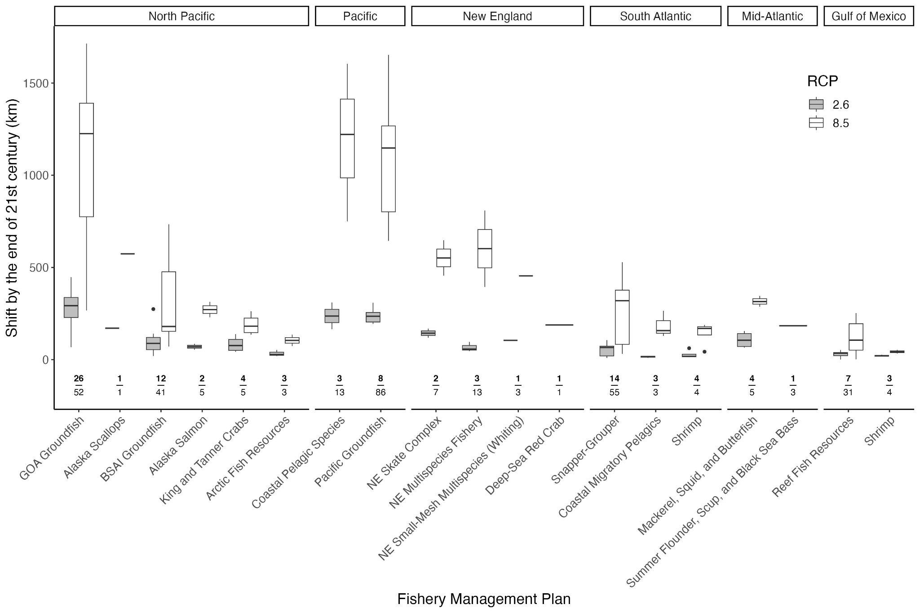

***Figure X.*** *The projected range shift of targeted species managed by each fishery management plan (FMPs) based on species distribution models by Morley et al. 2018 for low (RCP 2.6, grey) and high (RCP 8.5, white) emissions scenarios. FMPs are grouped by Fishery Management Council (FMC). FMC and FMPs decrease in magnitude of shift from left to right. The number of species in the FMP for which region-specific medium or high projections exist is printed above the FMP on the x-axis in bold above the total number of species managed by the FMP. Median projected range shift for FMP displayed as horizontal bar, interquartile range (IQR) as box, Q1&Q3 ± 1.5 * IQR in whiskers, and outliers as points.*

Climate-adaptive policy reform is most essential for stocks projected to experience extensive range shifts that have spatial allocation policies. The following stocks are high priority for reform:

* **Atlantic mackerel:** Atlantic mackerel *Scomber scombrus* is managed by the Mid-Atlantic Fisheries Management Council through the Mackerel, Squid, and Butterfish FMP. Within the northeast US, the species is expected to shift 65 km under a low emissions scenario, and 315 km under a high emissions scenario. This will pose a challenge for international allocation policies between the US and Canada, and therefore this species is a high priority for reform.
* **Black Sea Bass:** Black sea bass *Centropristis striata* is managed by the Mid-Atlantic Fisheries Management Council through the Summer Flounder, Scup, and Black Sea Bass FMP. Within the south Atlantic, the species is expected to shift 66 km under a low emissions scenario, and 530 km under a high emissions scenario. This shift in resource distribution will pose a challenge for state-based allocations and therefore this species is a high priority for reform and a transition to more dynamic allocation policies.
* **Bluefish:** Bluefish *Pomatomus saltatrix* is managed by the Mid-Atlantic Fisheries Management Council through the Bluefish FMP. Within the south Atlantic, the species is expected to shift 150 km under a low emissions scenario, and 580 km under a high emissions scenario. This will pose a challenge for state allocations as the stock moves north, and this species is therefore a strong candidate for more dynamics allocation policy.
* **Northern Anchovy:** Northern Anchovy *Engraulis mordax* is managed by the Pacific Fisheries Management Council through the Coastal Pelagic Species FMP. Along the US east coast, the species is expected to shift 235 km under a low emissions scenario, and 1220 km under a high emissions scenario. This will pose a challenge for international allocation policies between the US and Mexico, and therefore this species is a high priority for reform.
* **Pacific Ocean Perch:** The fishery for Pacific Ocean Perch *Sebastes alutus* in the Gulf of Alaska is managed by the North Pacific Fisheries Management Council through the Groundfish FMP. Within this region, the species is expected to shift 203 km under a low emissions scenario, and 770 km under a high emissions scenario. This will pose a challenge for spatial allocations across the Gulf, and therefore this species is a high priority for reform. Multiple other rockfish that are spatially allocated in the Gulf of Alaska are also expected to undergo large range shifts, making the GOA Groundfish FMP an especially good candidate for reform (ex. splitnose rockfish *S. diploproa*, aurora rockfish *S. aurora*, redbanded rockfish *S. babcocki,* shortraker rockfish *S. borealis* etc.).
* **Scup:** Scup *Stenotomus chrysops* is managed by the Mid-Atlantic Fisheries Management Council through the Summer Flounder, Scup, and Black Sea Bass FMP. Within the northeast US, the species is expected to shift 185 km under a low emissions scenario. Similar as for bluefish and black sea bass, this will pose a challenge for state allocations and therefore this species is high priority for reform and a transition to more dynamic allocation policies.

##### 5.2.3. Priority synthesis

Insert synthesis of CVA and projection results here.

### 

### 6. Conclusions

Allocations are a versatile fisheries management tool. They can reduce bycatch, improve efficiency, promote fairness and equity, e,fSeasonal allocations can prevent overages and race to fish.

* How do these recommendations relate to the rest of the world?
* How do these recommendations relate to state managed fisheries?
  + Many states implement their own allocation policies
* Allocations facilitated by:
  + “Allocation decisions are inextricably linked with data quality, whether the issues is having data that is comparable across sectors or of a fine enough resolution. The Western Pacific council set a combined recreational and commercial ACL for bottomfish, due to a lack of sector-specific catch data. The Caribbean council had sufficient recreational data to set a separate recreational ACLs for reef fish in Puerto Rico, but not in the U.S. Virgin Islands. Across councils the lack of comprehensive and timely recreational data collection under the Marine Recreational Fishing Statistics Survey has affected each council’s discussion of allocation in conjunction with ACLs and AMs.” FLSF 2010
  + “Data quality and availability will continue to set parameters for allocation decisions. The new, more robust Marine Recreational Information Program (MRIP) will generate more timely information and expand coverage of under and unsampled areas. Particularly in the Caribbean and Western Pacific, more information about recreational or non-commercial fisheries could permit sector allocations where data was previously insufficient. Allocation discussions may also prompt councils to reevaluate their data collection priorities. For example, if a council wishes to explore net economic benefit analysis as an allocation tool in the future, it will need to prioritize the data inputs that make these analyses possible. Decisions about data collection in the present will determine the range of options councils are able to consider, setting the stage for future allocation decisions.”FLSF 2010

### Acknowledgements

This research was funded by the Walton Family Foundation. We are grateful to the following council staffers for reviewing our allocation summaries: XYZ. We are also grateful to the following industry stakeholders for their feedback on the recommendations: XYZ.

### Data availability statement

All of the data used in the paper are either available in the supplemental materials or in the following GitHub repository: <https://github.com/zoekitchel/cc_allocation>

### Conflict of interests statement

CMF serves on the Scientific and Statistical Committee (SSC) of the Pacific Fisheries Management Council (PFMC). The other authors have no conflicts of interest to declare.

### Parking lot

* Interesting example
  + “Advancing tuna catch allocation negotiations: an analysis of sovereign rights and fisheries access arrangements”
  + <https://oceanequityresearch.org/news/an-analysis-of-sovereign-rights-and-fisheries-access-arrangements/>

Pozo Buil show big shifts for sardine which are managed with spatial allocation, less for anchovy

Pozo Buil M, Jacox M, Fiechter J, Alexander M, et al. (2021) A dynamically downscaled ensemble of future projections for the California Current System. Frontiers Marine Sciences, https://doi.org/10.3389/fmars.2021.612874

Bycatch ~ allocations (could potentially have a climate application)

* “Under the new MSRA requirements, bycatch plays a prominent role in allocation decisions. Hard allocations of bycatch species can be the currency that “funds” a fishery to operate. While hard bycatch allocations can constrain a fishery from achieving optimum yield, they can also incentivize selectivity. The New England and Pacific councils share the challenge of managing multispecies groundfish fisheries with healthy and overfished stocks. Many councils are finding that bycatch allocations create tradeoffs tied to the scale of management. Individual or cooperative bycatch allocations, allocations by region or by gear type can ensure that stakeholders have access to a resource, but small allocations can be constraining. Councils may choose to use fishery or sector-wide bycatch allocations to pool risk across participants, but may inadvertently create a race for bycatch.” FLSF 2010

**Lessons from game theory**

Game theory predicts the following for allocation rights to succeed (cox paper):

* An essential condition for stability is the perceived fairness and equity in the initial allocation.
* No matter how “fair” the allocation is, effective enforcement is required, otherwise it would be optimal for participants to defect before others cheat, and reap higher returns
* Optimal resource management over time will help to maximize the cooperative surplus
* Maximizing the cooperative surplus would also allow for the use of side payments, or “negotiation facilitators”
* The larger the number of players, the more difficult it is to achieve a stable cooperative arrangement due to greater enforcement problems and difficulties in reconciling conflicting objectives
* The need for agreements to be “resilient” in terms of having the flexibility to respond to external shocks.

**Random musings**

“Councils have used seasonal and regional apportionments to ensure that fleets in different regions have equitable access to migratory stocks, such as Pacific sardines and Gulf of Mexico king mackerel.” FLSF 2010

What scale is the most effective level to set allocation objectives and policies? As one example, Alaska has its own set of principles with the objective to directly support resident Alaskans.

### References

[§ 600.325 National Standard 4—Allocations, Pub. L. No. 600.325, 50 CFR (1998).](https://www.zotero.org/google-docs/?QTcmR9)

[§ 600.330 National Standard 5—Efficiency, Pub. L. No. 600.330, 50 CFR (1998). https://www.ecfr.gov/current/title-50/part-600/section-600.330](https://www.zotero.org/google-docs/?QTcmR9)

[Aqorau, T., Bell, J., & Kittinger, J. N. (2018). Good governance for migratory species. *Science*, *361*(6408), 1208–1209. https://doi.org/10.1126/science.aav2051](https://www.zotero.org/google-docs/?QTcmR9)

[Bahri, T., Vasconcellos, M., Welch, D. J., Johnson, J., Perry, R. I., Ma, X., & Sharma, R. (2021). *Adaptive management of fisheries in response to climate change* (FAO Fisheries and Aquaculture Technical Paper 667). United Nations Food and Agricultural Organization (FAO). https://doi.org/10.4060/cb3095en](https://www.zotero.org/google-docs/?QTcmR9)

[Bell, J. D., Ganachaud, A., Gehrke, P. C., Griffiths, S. P., Hobday, A. J., Hoegh-Guldberg, O., Johnson, J. E., Le Borgne, R., Lehodey, P., Lough, J. M., Matear, R. J., Pickering, T. D., Pratchett, M. S., Gupta, A. S., Senina, I., & Waycott, M. (2013). Mixed responses of tropical Pacific fisheries and aquaculture to climate change. *Nature Climate Change*, *3*(6), Article 6. https://doi.org/10.1038/nclimate1838](https://www.zotero.org/google-docs/?QTcmR9)

[Birkenbach, A. M., Kaczan, D. J., & Smith, M. D. (2017). Catch shares slow the race to fish. *Nature*, *544*(7649), Article 7649. https://doi.org/10.1038/nature21728](https://www.zotero.org/google-docs/?QTcmR9)

[Bonito, L., Bellquist, L., Jackson, A. M., Kauer, K., Gleason, M. G., Wilson, J., & Sandin, S. (2022). U.S. exempted fishing permits: Role, value, and lessons learned for adaptive fisheries management. *Marine Policy*, *138*, 104992. https://doi.org/10.1016/j.marpol.2022.104992](https://www.zotero.org/google-docs/?QTcmR9)

[Brinson, A., & Thunberg, E. (2016). Performance of federally managed catch share fisheries in the United States. *Fisheries Research*, *179*, 213–223. https://doi.org/10.1016/j.fishres.2016.03.008](https://www.zotero.org/google-docs/?QTcmR9)

[Burton, M. L., Muñoz, R. C., & Quinlan, J. A. (2023). *A Climate Vulnerability Assessment for Fish and Invertebrates in the United States South Atlantic Large Marine Ecosystem* (NOAA Technical Memorandum NMFS-SEFSC-768). Southeast Fisheries Science Center. https://repository.library.noaa.gov/view/noaa/55543](https://www.zotero.org/google-docs/?QTcmR9)

[Cline, T. J., Schindler, D. E., & Hilborn, R. (2017). Fisheries portfolio diversification and turnover buffer Alaskan fishing communities from abrupt resource and market changes. *Nature Communications*, *8*, 14042. https://doi.org/10.1038/ncomms14042](https://www.zotero.org/google-docs/?QTcmR9)

[Colburn, L. L., Jepson, M., Weng, C., Seara, T., Weiss, J., & Hare, J. A. (2016). Indicators of climate change and social vulnerability in fishing dependent communities along the Eastern and Gulf Coasts of the United States. *Marine Policy*, *74*, 323–333. https://doi.org/10.1016/j.marpol.2016.04.030](https://www.zotero.org/google-docs/?QTcmR9)

[Costello, C., Gaines, S. D., & Lynham, J. (2008). Can Catch Shares Prevent Fisheries Collapse? *Science*, *321*(5896), 1678–1681. https://doi.org/10.1126/science.1159478](https://www.zotero.org/google-docs/?QTcmR9)

[Cox, A. (2009). *Quota Allocation in International Fisheries* (OECD Food, Agriculture and Fisheries Papers 22; OECD Food, Agriculture and Fisheries Papers, Vol. 22). OECD Publishing. https://doi.org/10.1787/218520326143](https://www.zotero.org/google-docs/?QTcmR9)

[Edwards, S. F. (1990). *An economics guide to allocation of fish stocks between commercial and recreational fisheries* (NOAA Technical Report NMFS 94). https://repository.library.noaa.gov/view/noaa/5953](https://www.zotero.org/google-docs/?QTcmR9)

[Fisheries of New Zealand. (2024a). *Fisheries Infosite: Species Catch*. https://fs.fish.govt.nz/Page.aspx?pk=6&tk=97](https://www.zotero.org/google-docs/?QTcmR9)

[Fisheries of New Zealand. (2024b, May 27). *Commercial fishing annual catch entitlement (ACE)*. Ministry for Primary Industries; Ministry for Primary Industries. https://www.mpi.govt.nz/fishing-aquaculture/commercial-fishing/operating-as-a-commercial-fisher/commercial-fishing-annual-catch-entitlement/](https://www.zotero.org/google-docs/?QTcmR9)

[FLSF. (2010). *Allocation across the regional fishery management councils*. Fisheries Leadership & Sustainability Forum. https://nicholasinstitute.duke.edu/sites/default/files/publications/11420_FLSF_RegionalAllocationReport2010-paper.pdf](https://www.zotero.org/google-docs/?QTcmR9)

[Free, C. M., Anderson, S. C., Hellmers, E. A., Muhling, B. A., Navarro, M. O., Richerson, K., Rogers, L. A., Satterthwaite, W. H., Thompson, A. R., Burt, J. M., Gaines, S. D., Marshall, K. N., White, J. W., & Bellquist, L. F. (2023). Impact of the 2014–2016 marine heatwave on US and Canada West Coast fisheries: Surprises and lessons from key case studies. *Fish and Fisheries*, *24:*, 652–674. https://doi.org/10.1111/faf.12753](https://www.zotero.org/google-docs/?QTcmR9)

[Gaines, S. D., Costello, C., Owashi, B., Mangin, T., Bone, J., Molinos, J. G., Burden, M., Dennis, H., Halpern, B. S., Kappel, C. V., Kleisner, K. M., & Ovando, D. (2018). Improved fisheries management could offset many negative effects of climate change. *Science Advances*, *4*(8), eaao1378. https://doi.org/10.1126/sciadv.aao1378](https://www.zotero.org/google-docs/?QTcmR9)

[Giddens, J., Kobayashi, D. R., Mukai, G. N. M., Asher, J., Birkeland, C., Fitchett, M., Hixon, M. A., Hutchinson, M., Mundy, B. C., O’Malley, J. M., Sabater, M., Scott, M., Stahl, J., Toonen, R., Trianni, M., Woodworth-Jefcoats, P. A., Wren, J. L. K., & Nelson, M. (2022). Assessing the vulnerability of marine life to climate change in the Pacific Islands region. *PLOS ONE*, *17*(7), e0270930. https://doi.org/10.1371/journal.pone.0270930](https://www.zotero.org/google-docs/?QTcmR9)

[Hare, J. A., Morrison, W. E., Nelson, M. W., Stachura, M. M., Teeters, E. J., Griffis, R. B., Alexander, M. A., Scott, J. D., Alade, L., Bell, R. J., Chute, A. S., Curti, K. L., Curtis, T. H., Kircheis, D., Kocik, J. F., Lucey, S. M., McCandless, C. T., Milke, L. M., Richardson, D. E., … Griswold, C. A. (2016). A Vulnerability Assessment of Fish and Invertebrates to Climate Change on the Northeast U.S. Continental Shelf. *PLOS ONE*, *11*(2), e0146756. https://doi.org/10.1371/journal.pone.0146756](https://www.zotero.org/google-docs/?QTcmR9)

[Heen, E. E., Heen, K., & Leung, P. (2014). Conflicting goals in fisheries management—A study of the Norwegian cod fisheries. *Marine Policy*, *49*, 73–80. https://doi.org/10.1016/j.marpol.2014.03.014](https://www.zotero.org/google-docs/?QTcmR9)

[Himes-Cornell, A., & Kasperski, S. (2015). Assessing climate change vulnerability in Alaska’s fishing communities. *Fisheries Research*, *162*, 1–11. https://doi.org/10.1016/j.fishres.2014.09.010](https://www.zotero.org/google-docs/?QTcmR9)

[Holland, D. S., Speir, C., Agar, J., Crosson, S., DePiper, G., Kasperski, S., Kitts, A. W., & Perruso, L. (2017). Impact of catch shares on diversification of fishers’ income and risk. *Proceedings of the National Academy of Sciences*, *114*(35), 9302–9307. https://doi.org/10.1073/pnas.1702382114](https://www.zotero.org/google-docs/?QTcmR9)

[Hudson, M. (2022, July 6). *Māori hold a third of NZ’s fishing interests, but as the ocean warms and fish migrate, these rights don’t move with them*. The Conversation. http://theconversation.com/maori-hold-a-third-of-nzs-fishing-interests-but-as-the-ocean-warms-and-fish-migrate-these-rights-dont-move-with-them-186284](https://www.zotero.org/google-docs/?QTcmR9)

[IPCC. (2019). *IPCC Special Report on the Ocean and Cryosphere in a Changing Climate*. https://www.ipcc.ch/site/assets/uploads/sites/3/2022/03/SROCC_FullReport_FINAL.pdf](https://www.zotero.org/google-docs/?QTcmR9)

[Jenkins, L. D., & Garrison, K. (2013). Fishing gear substitution to reduce bycatch and habitat impacts: An example of social–ecological research to inform policy. *Marine Policy*, *38*, 293–303. https://doi.org/10.1016/j.marpol.2012.06.005](https://www.zotero.org/google-docs/?QTcmR9)

[Jepson, M., & Colburn, L. L. (2013). *Development of Social Indicators of Fishing Community Vulnerability and Resilience in the U.S. Southeast and Northeast Regions* (NOAA Technical Memorandum NMFS-F/SPO-129). U.S. Dept. of Commerce.](https://www.zotero.org/google-docs/?QTcmR9)

[Kauer, K., Bellquist, L., Humberstone, J., Saccomanno, V., Oberhoff, D., Flumerfelt, S., & Gleason, M. (2024). Advancing fisheries sustainability and access through community fisheries trusts. *Marine Policy*, *165*, 106210. https://doi.org/10.1016/j.marpol.2024.106210](https://www.zotero.org/google-docs/?QTcmR9)

[Knuckey, I., Sen, S., & McShane, P. (2019). *Review of fishery resource access and allocation arrangements across Australian jurisdictions* (FRDC Project 2017/122). Fishwell Consulting.](https://www.zotero.org/google-docs/?QTcmR9)

[Koehn, L. E., Nelson, L. K., Samhouri, J. F., Norman, K. C., Jacox, M. G., Cullen, A. C., Fiechter, J., Pozo Buil, M., & Levin, P. S. (2022). Social-ecological vulnerability of fishing communities to climate change: A U.S. West Coast case study. *PLOS ONE*, *17*(8), e0272120. https://doi.org/10.1371/journal.pone.0272120](https://www.zotero.org/google-docs/?QTcmR9)

[Kourantidou, M., Hoagland, P., Dale, A., & Bailey, M. (2021). Equitable Allocations in Northern Fisheries: Bridging the Divide for Labrador Inuit. *Frontiers in Marine Science*, *8*. https://doi.org/10.3389/fmars.2021.590213](https://www.zotero.org/google-docs/?QTcmR9)

[Lapointe, G. (2012). *Marine Fishery Allocation Issues: Findings, discussion, and options*. George Lapointe Consulting LLC.](https://www.zotero.org/google-docs/?QTcmR9)

[Lehodey, P., Bertignac, M., Hampton, J., Lewis, A., & Picaut, J. (1997). El Niño Southern Oscillation and tuna in the western Pacific. *Nature*, *389*(6652), 715–718. https://doi.org/10.1038/39575](https://www.zotero.org/google-docs/?QTcmR9)

[Lock, K., & Leslie, S. (2007). 3. Allocation, Trade and Holding of Quota. In *New Zealand’s Quota Management System: A History of the First 20 Years*. Motu Economic and Public Policy Research. https://fs.fish.govt.nz/NR/rdonlyres/C720A226-A8A9-46BE-87F3-3EABB8D7E248/0/qms_chapter_03_allocation_trade_holding.pdf](https://www.zotero.org/google-docs/?QTcmR9)

[Lynham, J. (2014). How have catch shares been allocated? *Marine Policy*, *44*, 42–48. https://doi.org/10.1016/j.marpol.2013.08.007](https://www.zotero.org/google-docs/?QTcmR9)

[MAFMC. (2021). *Bluefish Allocation And Rebuilding Amendment: Amendment 7 To The Bluefish Fishery Management Plan*. https://static1.squarespace.com/static/511cdc7fe4b00307a2628ac6/t/613104477cc5457c839fe04c/1630602830744/Bluefish+Amendment+7+EA.pdf](https://www.zotero.org/google-docs/?QTcmR9)

[MAFMC. (2024). *Research Set-Aside Program*. Mid-Atlantic Fishery Management Council. https://www.mafmc.org/research-set-aside](https://www.zotero.org/google-docs/?QTcmR9)

[Maine DMR. (2022). *Maine Groundfish Permit Bank*. Department of Marine Resources. https://www.maine.gov/dmr/fisheries/commercial/fisheries-by-species/groundfish-multispecies/maine-groundfish-permit-bank](https://www.zotero.org/google-docs/?QTcmR9)

[Mardle, S., Pascoe, S., Tamiz, M., & Jones, D. (2000). Resource allocation in the North Sea demersal fisheries: A goal programming approach. *Annals of Operations Research*, *94*, 321–342.](https://www.zotero.org/google-docs/?QTcmR9)

[Mason, J. G., Eurich, J. G., Lau, J. D., Battista, W., Free, C. M., Mills, K. E., Tokunaga, K., Zhao, L. Z., Dickey-Collas, M., Valle, M., Pecl, G. T., Cinner, J. E., McClanahan, T. R., Allison, E. H., Friedman, W. R., Silva, C., Yáñez, E., Barbieri, M. Á., & Kleisner, K. M. (2022). Attributes of climate resilience in fisheries: From theory to practice. *Fish and Fisheries*, *n/a*(n/a). https://doi.org/10.1111/faf.12630](https://www.zotero.org/google-docs/?QTcmR9)

[Maureaud, A. A., Palacios-Abrantes, J., Kitchel, Z., Mannocci, L., Pinsky, M. L., Fredston, A., Beukhof, E., Forrest, D. L., Frelat, R., Palomares, M. L. D., Pecuchet, L., Thorson, J. T., van Denderen, P. D., & Mérigot, B. (2024). FISHGLOB_data: An integrated dataset of fish biodiversity sampled with scientific bottom-trawl surveys. *Scientific Data*, *11*(1), 24. https://doi.org/10.1038/s41597-023-02866-w](https://www.zotero.org/google-docs/?QTcmR9)

[Mazur, K., Bath, A., Savage, J., & Curtotti R, R. (2020). *Allocating fish stocks between commercial and recreational fishers—Examples from Australia and overseas*. https://doi.org/10.25814/5EC4BD22339DA](https://www.zotero.org/google-docs/?QTcmR9)

[McClure, M. M., Haltuch, M. A., Willis-Norton, E., Huff, D. D., Hazen, E. L., Crozier, L. G., Jacox, M. G., Nelson, M. W., Andrews, K. S., Barnett, L. A. K., Berger, A. M., Beyer, S., Bizzarro, J., Boughton, D., Cope, J. M., Carr, M., Dewar, H., Dick, E., Dorval, E., … Bograd, S. J. (2023). Vulnerability to climate change of managed stocks in the California Current large marine ecosystem. *Frontiers in Marine Science*, *10*, 1103767. https://doi.org/10.3389/fmars.2023.1103767](https://www.zotero.org/google-docs/?QTcmR9)

[McShane, P., Knuckey, I., & Sen, S. (2021). Access and allocation in fisheries: The Australian experience. *Marine Policy*, *132*, 104702. https://doi.org/10.1016/j.marpol.2021.104702](https://www.zotero.org/google-docs/?QTcmR9)

[Morley, J. W., Selden, R. L., Latour, R. J., Frölicher, T. L., Seagraves, R. J., & Pinsky, M. L. (2018). Projecting shifts in thermal habitat for 686 species on the North American continental shelf. *PLOS ONE*, *13*(5), e0196127. https://doi.org/10.1371/journal.pone.0196127](https://www.zotero.org/google-docs/?QTcmR9)

[Morrison, W. (2016a). *Criteria for Initiating Fisheries Allocation Reviews Council Coordinating Committee Allocation Workgroup Guidance Document* (National Marine Fisheries Service Procedure 01-119–01). National Marine Fisheries Service.](https://www.zotero.org/google-docs/?QTcmR9)

[Morrison, W. (2016b). *Recommended Practices and Factors to Consider When Reviewing and Making Allocation Decisions* (National Marine Fisheries Service Procedure 01-119–02). National Marine Fisheries Service.](https://www.zotero.org/google-docs/?QTcmR9)

[Morrison, W. (2017a). *Catch Share Policy* (National Marine Fisheries Service Policy 01–121). National Marine Fisheries Service.](https://www.zotero.org/google-docs/?QTcmR9)

[Morrison, W. (2017b). *Fisheries Allocation Review Policy* (National Marine Fisheries Service Policy 01–119). National Marine Fisheries Service.](https://www.zotero.org/google-docs/?QTcmR9)

[Morrison, W. (2017c). *Guidance for Conducting Review of Catch Share Programs* (National Marine Fisheries Service Procedure 01-121–01). National Marine Fisheries Service.](https://www.zotero.org/google-docs/?QTcmR9)

[Morrison, W. E., Nelson, M. W., Griffis, R. B., & Hare, J. A. (2016). Methodology for Assessing the Vulnerability of Marine and Anadromous Fish Stocks in a Changing Climate. *Fisheries*, *41*(7), 407–409. https://doi.org/10.1080/03632415.2016.1182507](https://www.zotero.org/google-docs/?QTcmR9)

[Morrison, W. E., Nelson, M. W., Howard, J. F., Hare, J. A., Griffis, R. B., Scott, J. D., & Alexander, M. A. (2015). *Methodology for Assessing the Vulnerability of Marine Fish and Shellfish Species to a Changing Climate* (NOAA Technical Memorandum NMFS-OSF-3). National Marine Fisheries Service.](https://www.zotero.org/google-docs/?QTcmR9)

[Morrison, W. E., & Scott, T. L. (2014). *Review of Laws, Guidance, Technical Memorandums and Case Studies Related to Fisheries Allocation* (NOAA Technical Memorandum NMFS-F/SPO-148). National Marine Fisheries Service.](https://www.zotero.org/google-docs/?QTcmR9)

[NAS. (2024). *Assessing Equity in the Distribution of Fisheries Management Benefits: Data and Information Availability*. National Academies Press. https://doi.org/10.17226/27313](https://www.zotero.org/google-docs/?QTcmR9)

[Nayani, S., & Warlick, A. (2018). Implementation Challenges for Quota Set-Asides: Policy Analysis to Inform Fisheries Management Decision-Making. *Coastal Management*, *46*(6), 638–655. https://doi.org/10.1080/08920753.2018.1522493](https://www.zotero.org/google-docs/?QTcmR9)

[Neubauer, P., Thorson, J. T., Melnychuk, M. C., Methot, R., & Blackhart, K. (2018). Drivers and rates of stock assessments in the United States. *PLOS ONE*, *13*(5), e0196483-19. https://doi.org/10.1371/journal.pone.0196483](https://www.zotero.org/google-docs/?QTcmR9)

[Neville, P. (2012). *Principles and Guidelines in Support of Fisheries Inter-Sectoral Access and Allocation Decisions* [FRDC: Fisheries Resource Access and Allocation Project].](https://www.zotero.org/google-docs/?QTcmR9)

[NMFS. (1996). *50 CFR § 600.745—Scientific research activity, exempted fishing, and exempted educational activity*. https://www.govinfo.gov/content/pkg/CFR-2018-title50-vol12/pdf/CFR-2018-title50-vol12-sec600-745.pdf](https://www.zotero.org/google-docs/?QTcmR9)

[NOAA. (2024, May 2). *Research Set-Aside Programs*. NOAA Fisheries. https://www.fisheries.noaa.gov/new-england-mid-atlantic/funding-financial-services/research-set-aside-programs](https://www.zotero.org/google-docs/?QTcmR9)

[NOAA Fisheries. (2024, May 14). *Climate Vulnerability Assessment Tool* (National). https://www.fisheries.noaa.gov/data-tools/climate-vulnerability-assessment-tool](https://www.zotero.org/google-docs/?QTcmR9)

[NPFMC. (2016). *Twenty-Year Review of the Pacific Halibut and Sablefish Individual Fishing Quota Management Program*. North Pacific Fishery Management Council. https://www.npfmc.org/wp-content/PDFdocuments/halibut/IFQProgramReview_417.pdf](https://www.zotero.org/google-docs/?QTcmR9)

[Ojea, E., Pearlman, I., Gaines, S. D., & Lester, S. E. (2017). Fisheries regulatory regimes and resilience to climate change. *Ambio*, *46*(4), 399–412. https://doi.org/10.1007/s13280-016-0850-1](https://www.zotero.org/google-docs/?QTcmR9)

[Palacios-Abrantes, J., Crosson, S., Dumas, C., Fujita, R., Levine, A., Longo, C., & Jensen, O. P. (2023). Quantifying fish range shifts across poorly defined management boundaries. *PLOS ONE*, *18*(1), e0279025. https://doi.org/10.1371/journal.pone.0279025](https://www.zotero.org/google-docs/?QTcmR9)

[Palacios-Abrantes, J., Sumaila, U. R., & Cheung, W. (2020). Challenges to transboundary fisheries management in North America under climate change. *Ecology and Society*, *25*(4). https://doi.org/10.5751/ES-11743-250441](https://www.zotero.org/google-docs/?QTcmR9)

[Papaioannou, E. A., Selden, R. L., Olson, J., McCay, B. J., Pinsky, M. L., & St. Martin, K. (2021). Not All Those Who Wander Are Lost – Responses of Fishers’ Communities to Shifts in the Distribution and Abundance of Fish. *Frontiers in Marine Science*, *8*. https://doi.org/10.3389/fmars.2021.669094](https://www.zotero.org/google-docs/?QTcmR9)

[PFMC. (2021, September). *Pacific Coast Salmon Fishery Management Plan*. Pacific Fishery Management Council. https://www.pcouncil.org/documents/2016/03/salmon-fmp-through-amendment-20.pdf/](https://www.zotero.org/google-docs/?QTcmR9)

[PFMC. (2023). *Implementing council efficiencies in line with the grant application process staff white paper* (Agenda Item C.2 Attachment 1). Pacific Fishery Management Council. https://www.pcouncil.org/documents/2023/06/c-2-attachment-1-implementing-council-efficiencies-in-line-with-the-grant-application-process.pdf/](https://www.zotero.org/google-docs/?QTcmR9)

[PFMC & NMFS. (2010). *Rationalization of the Pacific Coast Groundfish Limited Entry Trawl Fishery; Final Environmental Impact Statement Including Regulatory Impact Review and Initial Regulatory Flexibility Analysis*. Pacific Fishery Management Council.](https://www.zotero.org/google-docs/?QTcmR9)

[Pinsky, M. L., & Fogarty, M. (2012). Lagged social-ecological responses to climate and range shifts in fisheries. *Climatic Change*, *115*(3), 883–891. https://doi.org/10.1007/s10584-012-0599-x](https://www.zotero.org/google-docs/?QTcmR9)

[Pinsky, M. L., Reygondeau, G., Caddell, R., Palacios-Abrantes, J., Spijkers, J., & Cheung, W. W. L. (2018). Preparing ocean governance for species on the move. *Science*, *360*(6394), 1189–1191.](https://www.zotero.org/google-docs/?QTcmR9)

[Pinsky, M. L., Worm, B., Fogarty, M. J., Sarmiento, J. L., & Levin, S. A. (2013). Marine taxa track local climate velocities. *Science*, *341*(6151), 1239–1242. https://doi.org/10.1126/science.1239352](https://www.zotero.org/google-docs/?QTcmR9)

[Plummer, M., Morrison, W., & Steiner, E. (2012). *Allocation of Fishery Harvests under the Magnuson-Stevens Fishery Conservation and Management Act: Principles and Practice* (NOAA Technical Memorandum NMFS-NWFSC-115.). Northwest Fisheries Science Center.](https://www.zotero.org/google-docs/?QTcmR9)

[PNA Tuna. (2010). *Nauru Agreement Concerning Cooperation in the Management of Fisheries of Common Stocks (as Amended April 2010)*. PNA Tuna. https://www.pnatuna.com/content/nauru-agreement](https://www.zotero.org/google-docs/?QTcmR9)

[PNA Tuna. (2011). *Purse Seine PNA Vessel Day Scheme*. PNA Tuna. https://www.pnatuna.com/content/pna-vessel-day-scheme](https://www.zotero.org/google-docs/?QTcmR9)

[Productivity Commission. (2016). *Marine Fisheries and Aquaculture, Final Report* (Productivity Commission Inquiry Report 81). Commonwealth of Australia. https://www.pc.gov.au/inquiries/completed/fisheries-aquaculture/report/fisheries-aquaculture.pdf](https://www.zotero.org/google-docs/?QTcmR9)

[Punt, A. E. (2010). Harvest Control Rules and Fisheries Management. In R. Q. Grafton, R. Hilborn, D. Squires, M. Tait, & M. J. Williams (Eds.), *Handbook of Marine Fisheries Conservation and Management* (p. 13). Oxford University Pres.](https://www.zotero.org/google-docs/?QTcmR9)

[Quinlan, J. A., Nelson, M., & Caitlyn Savoia. (2023). *Results from the Gulf of Mexico Climate Vulnerability Analysis for Fishes and Invertebrates* (NOAA Technical Memorandum NMFS-SEFSC-767). Southeast Fisheries Science Center. https://repository.library.noaa.gov/view/noaa/55544](https://www.zotero.org/google-docs/?QTcmR9)

[Samhouri, J. F., Feist, B. E., Jacox, M., Liu, O. R., Richerson, K., Steiner, E., Wallace, J., Andrews, K., Barnett, L., Beaudreau, A. H., Bellquist, L., Buil, M. P., Haltuch, M. A., Harley, A., Harvey, C. J., Kaplan, I. C., Norman, K., Phillips, A., Rasmuson, L. K., … Selden, R. L. (2024). Stay or go? Geographic variation in risks due to climate change for fishing fleets that adapt in-place or adapt on-the-move. *PLOS Climate*, *3*(2), e0000285. https://doi.org/10.1371/journal.pclm.0000285](https://www.zotero.org/google-docs/?QTcmR9)

[Scherrer, K. J. N., Langbehn, T. J., Ljungström, G., Enberg, K., Hornborg, S., Dingsør, G., & Jørgensen, C. (2024). Spatial restrictions inadvertently doubled the carbon footprint of Norway’s mackerel fishing fleet. *Marine Policy*, *161*, 106014. https://doi.org/10.1016/j.marpol.2024.106014](https://www.zotero.org/google-docs/?QTcmR9)

[Spencer, P. D., Hollowed, A. B., Sigler, M. F., Hermann, A. J., & Nelson, M. W. (2019). Trait‐based climate vulnerability assessments in data‐rich systems: An application to eastern Bering Sea fish and invertebrate stocks. *Global Change Biology*, *25*(11), 3954–3971. https://doi.org/10.1111/gcb.14763](https://www.zotero.org/google-docs/?QTcmR9)

[Tokunaga, K., Kerr, L. A., & Pershing, A. J. (2023). Implications of fisheries allocation policy on anticipated climate change impacts. *Marine Policy*, *148*, 105402. https://doi.org/10.1016/j.marpol.2022.105402](https://www.zotero.org/google-docs/?QTcmR9)

[US GAO. (2020). *Mixed-Use Fisheries: South Atlantic and Gulf of Mexico Councils Would Benefit from Documented Processes for Allocation Reviews* (Report to Congressional Committees GAO-20-216). United States Government Accountability Office. https://www.gao.gov/assets/gao-22-105132.pdf](https://www.zotero.org/google-docs/?QTcmR9)

[US GAO. (2022). *Opportunities Exist to Enhance Climate Resilience* (Report to Congressional Committees GAO-22-105132). United States Government Accountability Office. https://www.gao.gov/assets/gao-22-105132.pdf](https://www.zotero.org/google-docs/?QTcmR9)

[Vogel, J. M., Levine, A., Longo, C., Fujita, R., Alves, C. L., Carroll, G., Craig, J. K., Dancy, K., Errend, M., Essington, T. E., Farchadi, N., Glaser, S., Golden, A. S., Jensen, O. P., LeFlore, M., Mason, J. G., Mills, K. E., Palacios-Abrantes, J., Rogers, A., … Wabnitz, C. C. C. (2024). Fisheries in flux: Bridging science and policy for climate-resilient management of US fisheries under distributional change. *Marine Policy*, *170*, 106385. https://doi.org/10.1016/j.marpol.2024.106385](https://www.zotero.org/google-docs/?QTcmR9)

[Walters, C. J. (2007). Is Adaptive Management Helping to Solve Fisheries Problems? *AMBIO: A Journal of the Human Environment*, *36*(4), 304–307. https://doi.org/10.1579/0044-7447(2007)36[304:IAMHTS]2.0.CO;2](https://www.zotero.org/google-docs/?QTcmR9)

[Walters, C. J., & Hilborn, R. (1976). Adaptive Control of Fishing Systems. *Journal of the Fisheries Research Board of Canada*, *33*(1), 145–159. https://doi.org/10.1139/f76-017](https://www.zotero.org/google-docs/?QTcmR9)

[Young, T., Fuller, E. C., Provost, M. M., Coleman, K. E., St. Martin, K., McCay, B. J., & Pinsky, M. L. (2019). Adaptation strategies of coastal fishing communities as species shift poleward. *ICES Journal of Marine Science*, *76*(1), 93–103. https://doi.org/10.1093/icesjms/fsy140](https://www.zotero.org/google-docs/?QTcmR9)

### 

### Tables and Figures

**Figure 1.** Example flow charts.

**Figure 2.** Map and spatial allocations.

**Figure 3.** Sector-based allocations.

**Figure 4.** Catch share allocations.

**Figure 5.** Adaptive management.

**Figure 6.** Equity schematic.

**Figure 7.** Distribution shift

### Supplemental Tables and Figures

**Table S1.** Database policy.

We haven’t quite figured out how to record the unit of the allocation itself or the basis of the allocation.

| **Description** | **Column name** | **Example** | **Status / notes** |
| --- | --- | --- | --- |
| Council | council | NEFMC |  |
| Management plan | fmp | Northeast Multispecies |  |
| Stock name | stock | Granger fish - Georges Bank |  |
| Species category | spp_catg | Groundfish | Add when DB is done |
| Common name | comm_name | Granger fish | Add when DB is done |
| Scientific name | sci_name | *Petrificus totalus* | Add when DB is done |
| Catch prohibited (yes/no)? | prohibited_yn | No |  |
| Allocation rule (yes/no)? | allocation_yn | Yes |  |
| Geographic rule (yes/no)? | spatial_yn | Yes | Derive programmatically |
| Country rule (yes/no)? | country_yn | Yes | Derive programmatically |
| List of countries | country_list | US, Canada |  |
| Number of countries | county_n | 2 | Derive programmatically |
| Country reference years | country_yrs | 1985-1990, 1995-2001 |  |
| State rule (yes/no)? | state_yn | Yes |  |
| List of states | state_list | ME, NH, RI |  |
| Number of states | state_n | 3 |  |
| State reference years | state_yrs | 1985-1990 |  |
| Area (yes/no)? | area_yn | Yes |  |
| List of areas | area_list | Georges Bank, Gulf of Maine |  |
| Number of areas | area_n | 2 | Derive programmatically |
| Area reference years | area_yrs | 1985-1990, 1995-2001 |  |
| Sector rule (yes/no)? | sector_yn | Yes |  |
| List of sectors | sector_list | Research, comm, rec, tribal |  |
| Number of sectors | sector_n | 3 |  |
| Basis (catch/effort) | sector_basis | Catch |  |
| Sector reference years | sector_yrs | 1985-1990 |  |
| Subsector rule (yes/no)? | subsector_yn | Yes |  |
| List of subsectors | subsector_list | Longline, gillnet, trap |  |
| Number of subsectors | subsector_n | 3 | Derive programmatically |
| Subsector reference years | subsector_yrs | 1985-1990, 1995-2001 |  |
| Seasonal rule (yes/no)? | season_yn | Yes |  |
| List of seasons | season_list | Jan - May, Jun - Dec |  |
| Number of seasons | season_n | 2 | Derive programmatically |
| Indiv/group rule (yes/no)? | indiv_yn | Yes |  |
| Basis (hist., equal, auction | indiv_basis | Historical catch |  |
| Reference years | indiv_yrs | 1985-1990 |  |
| Owner | indiv_owner | Vessel |  |
| Share caps (yes/no)? | indiv_caps_yn | Yes |  |

### 

**Figure X.** Sector-based allocation policies documented by Morrison and Scott (2014). Panel **A** shows the percent of quota allocated to commercial and recreational fisheries by council and stock. Stocks are sorted in order of increasing allocations to recreational fisheries. The vertical dashed line indicates a 50:50 split. Panel **B** shows the reference period used to derive the allocation policy (lines) and the year in which the allocation policy went into effect (points). A few policies weigh the recent time period in addition to the selected reference time period.

Database policies

* Describe methods for finding/describing allocation policies
  + Sector-based (commercial, recreational, for-hire)
  + Entity-based (catch shares, ITQs, LAPP)
  + Species-specific (Individual bluefin quota (IBQ))
  + Rights-based (indigenous groups and tribes)
  + Temporal (phase-in/out)
  + Spatial (state, county, etc.)
  + Combination
* Describe distribution of allocation rule types by region and fishery type
* Tease up the climate resilient insights revealed by these policies
* Database structure
  + Fishery traits
    - Council
    - FMP
    - Taxa group
    - Species
  + Allocation rule types
    - States
      * alloc_by_state
    - Sectors (e.g., recreational, commercial, tribal)
      * alloc_by_sector_rec
      * alloc_by_sector_com
      * alloc_by_sector_trib
    - Gears
      * alloc_by_gear
    - Individuals or groups (e.g., cooperatives)
      * alloc_by_indiv
    - Space (e.g., inshore/offshore)
      * alloc_by_space
    - Time (e.g., seasons)
  + Individual/group allocations (RBFM)
    - Allocation approach (historical catch/effort, equal share, auction, etc)
      * alloc_by_history
      * alloc_by_equal
      * alloc_by_auct
    - Unit of shares (e.g., catch, effort, area)
      * indiv_share_unit
    - Transferability of shares (transferable, not transferable)
      * indiv_transfer_yn
    - Owner of shares (individual, vessel, cooperative)
      * indiv_owner

Something about whether percentages are fixed (static) or are dynamic?